Dayton Public Schools
Intro to Orff Schulwerk
Clinician: Sue Mueller

January 16, 2018

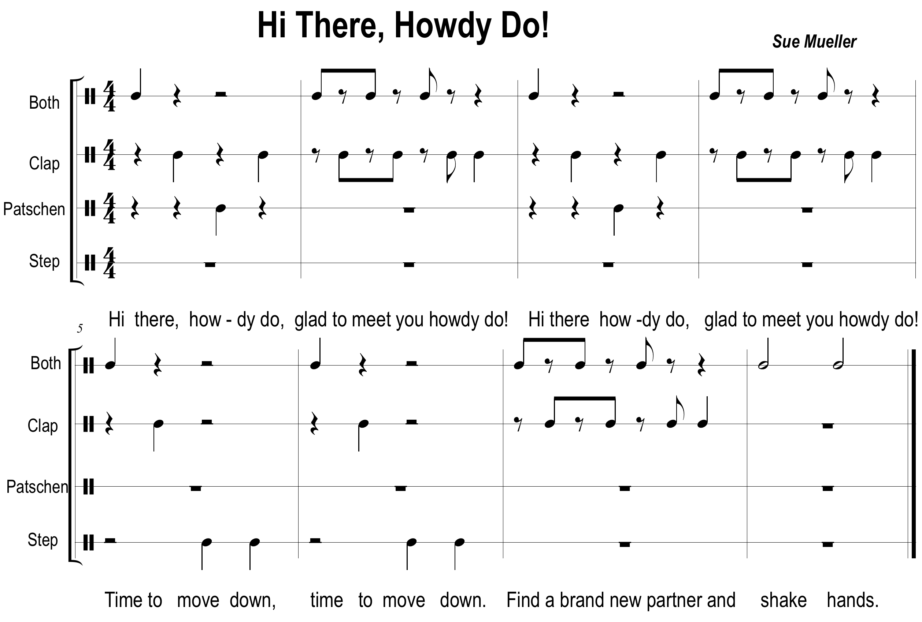

Teaching sequence: Circle formation
- Teacher speaks poem while students keep pulse mirroring teacher “both-clap-patschen-clap”
- Continue above body percussion pattern, echo words until learned.
- Teach new body percussion and movement until comfortable speaking the words and executing body percussion.
- Concentric Circles: Partners facing
- Practice body percussion with partner, then add words.
- At the end, each will have a new partner.

Introduction

On Orff the educator and Orff the composer

Carl Orff is a dramatist whose work is a fusion of language with gesture; of rhythm with dance. These elements are clearly visible in works such as Carmina Burana and Antigone.
This established relationship of rhythm, sound and dance are the basis for Das Schulwerk (The Schoolwork). Since its inception in the 1930s, it opened a new approach to music education. It is an open-ended approach to music-making, rather than a methodology. At its heart is the reliance on improvisation. It joins together speech, song and movement to allow for the fullest individual expression. Through this unity, all musical elements are explored, imitated and improvised, culminating in music literacy.
As in his compositions, Orff's approach uses timbre, rhythm, speech and ostinato to build elemental sound pieces. Not to be misunderstood to only apply to elementary students, elemental music, is not abstract music- but that which integrates the elements of speech, movement and dance. The energy and vitality of this elemental music with rhythm as the basic element in music, dance and speech stirs the imagination of children, and so easily initiates opportunities for their creative input. Drums, recorders, xylophones, non-pitched percussion, joyous dancing, improvisation – what could be more joyous?

Orff Schulwerk and education

Music educators trained in the Orff approach provide building blocks from which students can freely express themselves with speech, song, movement and instruments. Through immersion in exploration and imitation, students learn how to create their own compositions. The teacher is then no longer the director, but rather the knowing facilitator in the many-faceted, sophisticated experiential process.
Education in the arts is not only about literacy, although that is most certainly not to be ignored. Arts education develops expressive individuals who posses vital problem-solving skills. They are equipped to live in an ever-changing society while maintaining their independence, and they can work cooperatively with their neighbors and colleagues in a diverse society.
The Schulwerk approach fosters this process. In an increasingly technological society, it has become too easy to avoid interaction with others altogether. Through the Internet, we order anything we want, take classes, conduct business and communicate with one another online – all without ever speaking or meeting another human being face-to-face.
The unifying qualities of the Schulwerk hold the promise of reconnection for our students in such a world. It nurtures the connection to humanity. We are funding countless worthwhile projects that create opportunities in the sciences. However, without the recognition – and development – of the artist within each student, those projects fall on closed minds. The arts cross all ethnic lines, age groups and belief systems. And it is arts education that allows the creative expression and sturdy independence our children need.

Welcome to Orff Schulwerk!

RHYTHM

THE ONTOGENESIS OF RHYTHM
Rhythmic training in Orff Schulwerk follows developmental levels (ontogenesis). We teach to the child in his/her ability range and according to age. We start with the simple and move to the complex, all in accordance with the developmental level of the student.

Beginning with IMITATION, the most natural place to start, we will move through EXPLORATION, IMPROVISATION AND VISUALIZATION. Although it might be easy for a student to DO something at one level, say imitation, it should not be concluded that the student is ready for another level, for example, visualization. Each step is important in the whole PROCESS of teaching. Below is a suggested guide to help understand this development. The grade levels are suggestions and flexible as all teaching environments are different.

Grade? only suggested | Note Values and Rests | Meter | Body Perc.  levels
K-1 | Sound/silence should be explored first;  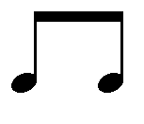 | Convergent; Duple, simple & compound  2/4, 6/8 | One level
2 | 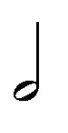 | Convergent; Duple, simple & compound,  2/4, 6/8 | Move to any two levels
3 | 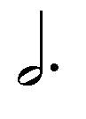  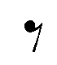 | Convergent;  3/4, 3/8,4/4 | Still any two levels
4 | 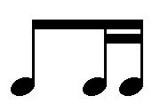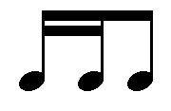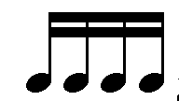 | Divergent; syncopation, triplets,  5/8,7/8, | Three or four levels
5 | 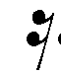  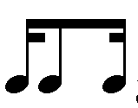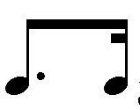  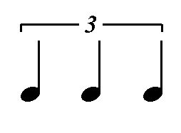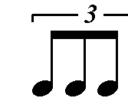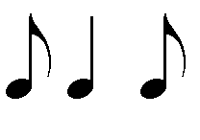 | Divergent;  Dotted, off beats | Three or four levels

One level of body percussion  leads to  Four levels of body percussion  Keep predictable patterns when using all 4 levels; for example:  snap, clap, patschen, stomp or  stomp, patshcen, clap snap | Convergent rhythms  rhythms whose natural accents fall (converge) on the beat.  leads to  Divergent rhythms  rhythms that do NOT coincide with the beat (off beats, syncopation, dotted rhythms, triplets) | 2/4  then  6/8  then  3/4  And beyond…  (5/4, 7/8, etc)

Examples:

CONVERGENT rhythms: These are rhythms whose natural accents fall (converge) on the beat. Example:
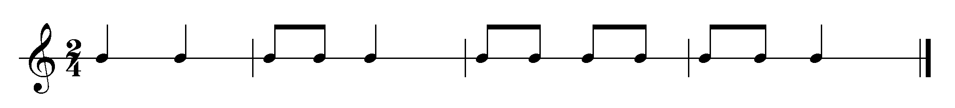
DIVERGENT rhythms: Divergent rhythms are those that do NOT coincide with the beat (off beats, syncopation). These rhythms are presented when the student can internalize the steady beat. Example:
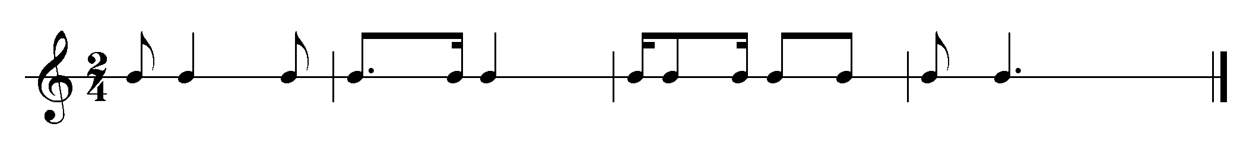

HOW TO BEGIN IMITATION

BODY PERCUSSION:
- 4- measures, 2/4, 6/8; then add different meters as ready
- one level of body percussion (claps usually are first); add more as ready-one at a time (i.e. -clap; clap-patsch; clap-patsch-snap; clap-patsch-snap-stomp)
- convergent rhythms; add divergent when secure

UNPITCHED PERCUSSION:
- all echo patterns together
- then echo in families: woods, metals, drums, large percussion

PITCHED PERCUSSION:
- all echo patterns together
- divide into families or other combinations as available instrument allow
Voice | Body Percussion | Unpitched | Pitched
Soprano | Snap | Metals | Soprano Glockenspiel
Alto | Clap | Woods | AG/SX/SM
Tenor | Patschen | Membranes | AX/AM
Bass | Stomp | Large Percussion | BX/BM  (CBB-8va lower)

SUGGESTIONS FOR LEADING ECHO WORK
(students will lead patterns for echo in class on DAY 3)

- Begin with simple patterns and repeat if the pattern is not accurate.
(remember what you clapped)
- Keep phrase length consistent. The students should be able to anticipate your ending and their beginning.
- End your pattern on a strong beat, perhaps with a rest at the end.

- Add only one new level at a time.
- When three or more levels are involved, it is easier in a consecutive manner
(high to low; low to high)
- Think the whole phrase, make it musical, explore different body percussion timbres LISTEN to the students- don't do it with them.

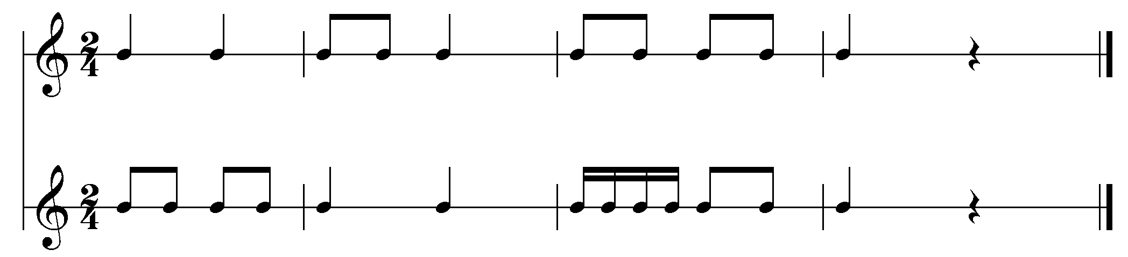

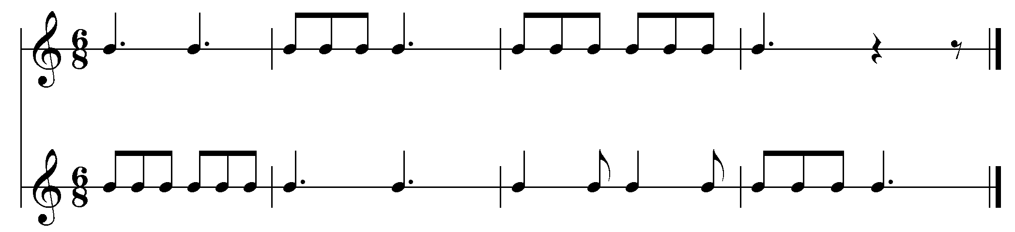
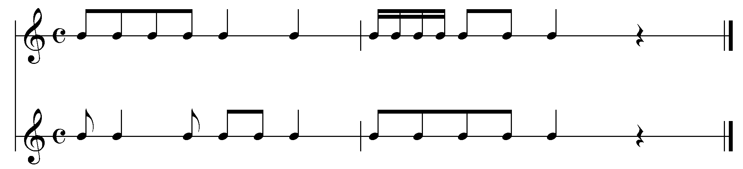
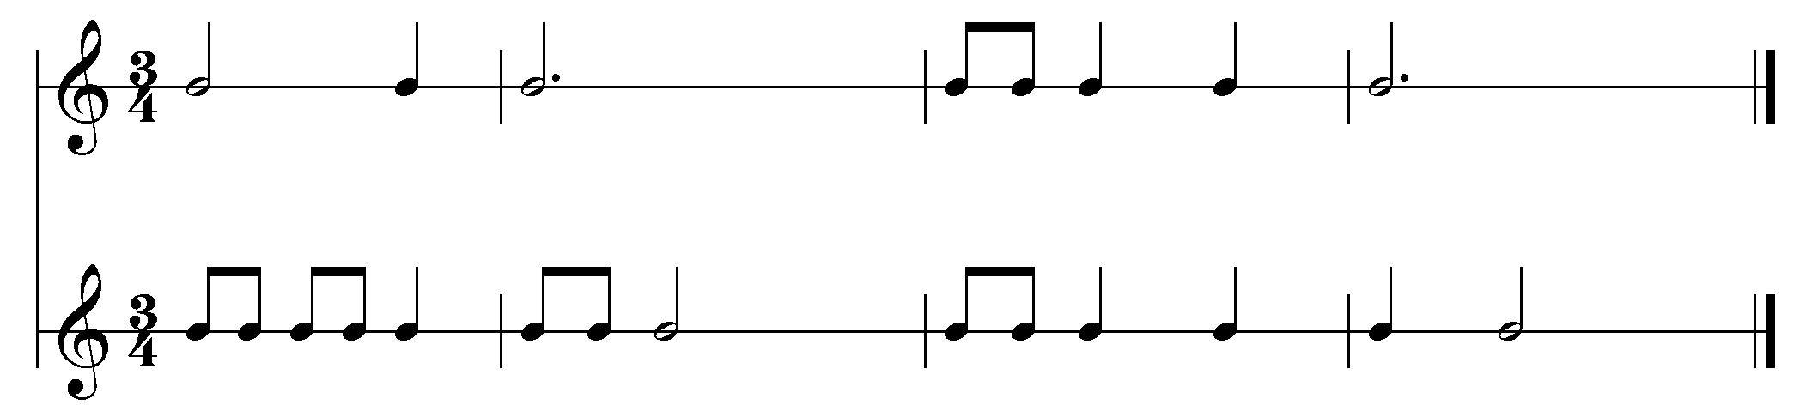

PULSE

The understanding of pulse vs. rhythm is necessary to build good musicianship and intelligent musical performance. Steady beat lends stability, the glue that holds everything else together. Without a purposeful building of this skill, most activities fall apart, have to be held together by the teacher or re-started many times. When there is a strong, carefully developed responsiveness to pulse, ensemble activities are quite rewarding and improvisation easier.
Many activities with children, concerning pulse awareness, are kinesthetic. Children love to move, whether it be tapping their foot, skipping, jumping, climbing. This instinctive love of moving should be fostered through rhythmic play and movement activities that refine ability to express character or mood of music, poetry,

RHYTHM PATTERNS

Rhythm patterns emerge through pulse activities through speech material-names, poems, rhymes. This should be an out-growth of beat competency. Through this comes the natural phrasing and accents/meter that come through the flow of the speech. Young children will use the terms interchangeably unless you constantly reinforce which is which. Consider activities that first address students doing something to the pulse followed immediately by demonstrating (clap, patsch) the rhythm (usually the words to a poem).

Once students have developed good imitation skills, through speech, movement and rhythmic activities, the student is led towards improvisation and creation. Students respond by making up or creating an answer to a given question through a question and answer approach in body percussion, speech, song. As this skill develops, the student eventually is able to create entire Q/A of their own. Imitation, exploration, improvisation-approach used throughout the course.

PULSE ACTIVITY SPEAKING WITH PULSE
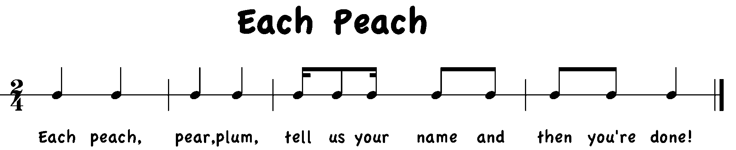

Teaching Sequence:
- Seated circle; passing yellow yarn ball; student leader (with yarn ball) speaks name within an 8-beat phrase while showing what part of the body to keep beat on; all pat with both hands that body part, speaking the name of the body part at the same time
- Pass yarn ball to next person, who shows a different place to keep beat while speaking name.

SPOKEN RHYME WHILE MOVING PULSE

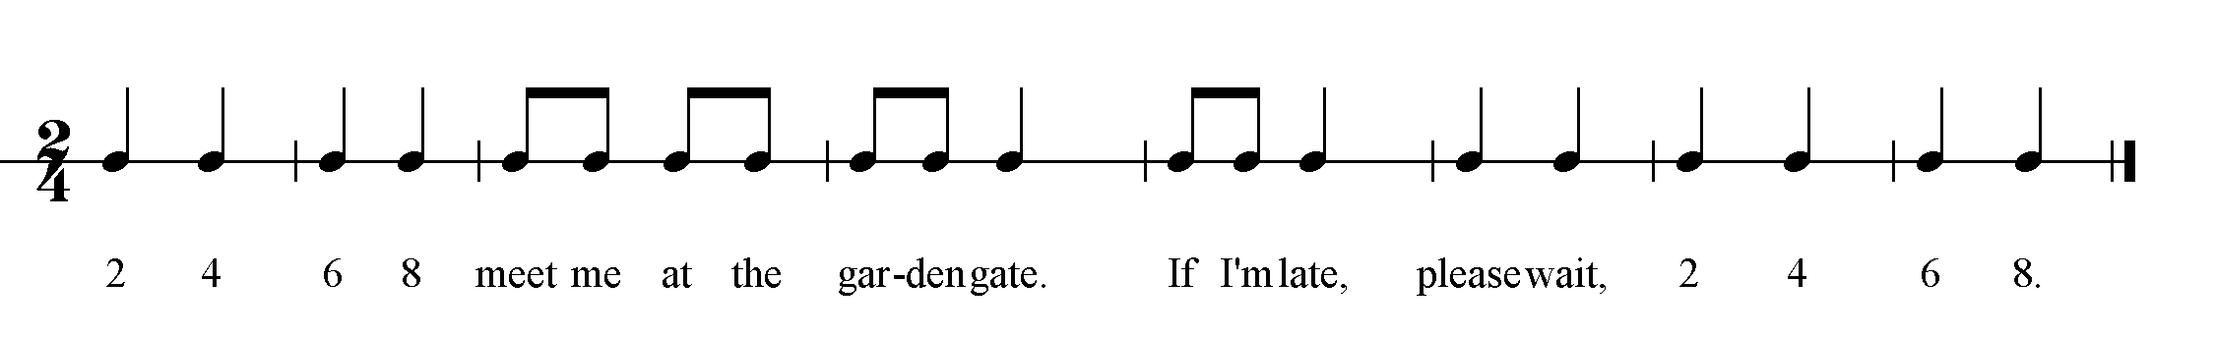

Teaching Sequence:

- speak poem through echo keeping pulse on body; keep pulse walking
- speak poem and decide who is at the garden gate, showing how you will get there; (dentist?-slowly; boyfriend?-quickly; millionaire?-very quickly!)
- transfer movement to walk large steps; walk; jog and practice speaking poem with each.
- Transfer movement to *patsch ; add poem; transfer to W.B.
*patsch ; add poem; transfer to H.D,
*patsch ; add poem; transfer to jingle bells or
tambourine
- Final form: Speak poem

Clap rhythm of poem with each instrumental note value alone
Combine all note values and speak poem

NOTATING THE PULSE-Labeling quarter note and rest

Apples S.M.
Red ones, green ones
Grow on trees ones
In my mouth ones
Good for me!

Teaching Sequence:
- Speak poem patsching pulse
- Speak poem while teacher notates, (quarter note) the pulse, students patsch
- Speak poem, student points to pulse representation; Label silent beat at end as quarter rest. *Game: T points to apple icon, ST play one sound per apple on lummi sticks. At end of poem a ST turns over an apple (rest) and class repeats poem, making no sound on apple turned over (apple turn-over?)
- Class can create a spoken interlude to provide transition for ST turning card.

PITCHED PERCUSSION

Beginning experiences with the barred instruments is magical. Understanding of the timbre, and qualities of each family of the instruments is crucial to making exciting orchestrations and magical experiences for children. Always model and insist on proper mallet technique and give opportunities through imitation, exploration and improvisation.

EXPLORATION:
- At given start cue students play freely in a pentatonic scale, stopping on given stop cue-teacher is the conductor
- Choose student conductor (with a puppet or 'magic wand' makes it fun)
- Respond to high, middle, low ranges of instruments
- Try a 'sound wave'- students start on a chosen side of row of instruments and play a glissando from low to high end as teacher wave over their instrument

IMITATION:
- Echo teacher's clapped rhythm on your instrument
- Echo only your corresponding body percussion;
Claps = woods snaps = metals
- Continue to refine further;
Snaps = glockenspiels; Claps = metallophones; Patschen = xylophones

CLASSROOM EXAMPLE: Lower Grades
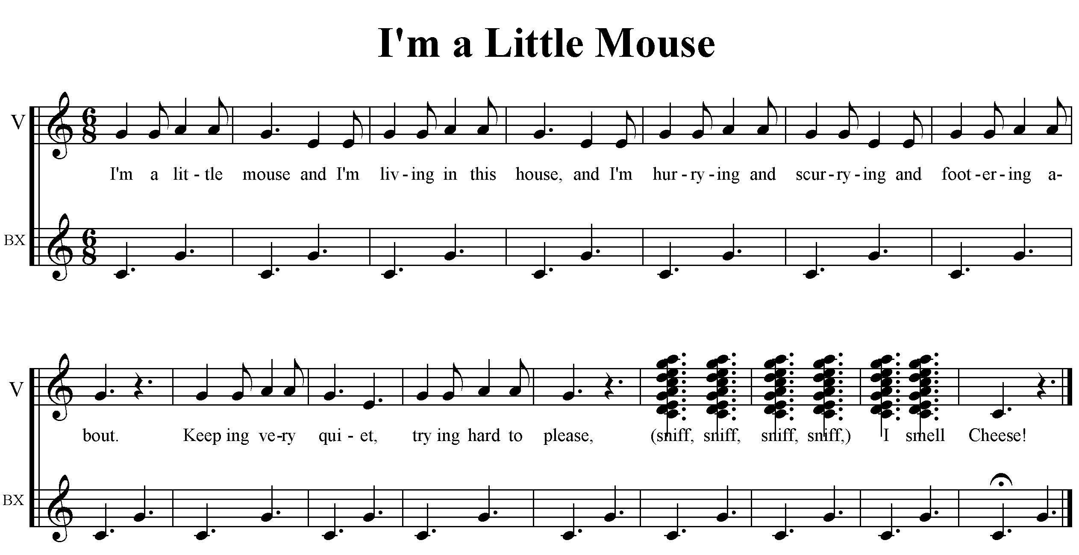
Teaching Sequence:
- Echo poem or sing with sol-mi-la
- Students patschen the last phrase
- Transfer patsch to any notes on instrument set in a pentatonic scale
- Rotate to a new instrument saying following words;
Interlude:
"Moving to the next house, looking for the cheese, waiting for my turn very patiently!"

CLASSROOM EXAMPLE: Upper Grades

_________________ ELEMENTARY MUSIC CURRICLUM
Grade: 4 Lesson Sequence No:

Anticipatory Set:

- Students have had previous experience playing barred instruments. Students understand the construct of pentatonic scales C, F, and G pitch sets.
- Students understand the difference between eighth, quarter, and half notes;
- Students have played a chord bordun)

Learning Outcomes:

Target Outcome:
- Students will be able to classify the timbre of barred instruments through improvisation in a pentatonic key.

Other Outcomes:
- Students will be able to demonstrate the difference between steady beat and rhythm of text/song responding to quarter, half, and eighth note values through listening, movement, and playing.
- Students will play a 2-measure chord bordun ostinato while singing a song.
- Students will demonstrate understanding of rondo form by playing at the correct time on the improvised section.

Pre-class Preparation:

- Barred instruments, technology, pictures of instrument groups

Vocabulary:
Timbre
Ostinato
Bordun
Quarter Note
Eighth Note
Half Note
Pentatonic
Beat
Rhythm of Words
Xylophone
Metallophone
Glockenspiel, (woods, metals)

Assessment(s): Auditory, Kinesthetic

- Students identify the timbre of the group of instruments by listening to the timbre and displaying the appropriate name (xylophone, metallophone, glockenspiel)
- Students demonstrate moving and playing to quarter, eighth, and half note pulse.
- Students play a 2-measure chord bordun ostinato while singing a song.

Sequence of Instruction:  - Warm-up:  Good morning. Today when you enter the room, walk the quarter note beat that matches what I play on the xylophone. When I change instruments, match the new beat in your walk.  - Students enter the room walking the pulse matching the quarter note pulse teacher plays on xylophone.  - Students walk half note pulse when teacher plays half notes on metallophone.  - Students jog eighth note pulse when teacher plays eighth notes on glockenspiel.  - Students are seated to discuss the difference in the pulse they walked and the difference in timbre played by teacher  You walked the quarter note beat when I played the xylophone. How did your beat change when I played the metallophone, and glockenspiel? You used quarter, eighth, and half notes in your movement.  - Play/Improvise:  We have three different types of pitched percussion instruments, xylophones, metallophones, and glockenspiels. What are the differences in the way they sound?  - Students are led to discover the different timbre of each group of barred instruments.  We call these differences “timbre”. I am going to use the quarter, eighth, and half note values and clap some patterns.  As you move to your instrument, echo the patterns I clap.  - Students react to the note values teacher claps and moves to the instruments in an orderly manner.  - Students set instruments in C pentatonic.  Now, when I clap a pattern, play that same pattern on any note on your instrument. Remember to play gently, and never, never pound!  - In C pentatonic, students improvise rhythms clapped by the teacher, playing any notes in the C pentatonic scale on xylophones, metallophones and glockenspiels.  - Sing:  We are going to learn a song that helps us to remember the three timbre groups of our barred instruments. You will also be able to play your own song, improvising.  - Students learn song through echo process, singing.  - Echo song by phrase, patschen on knees to quarter, and then half note pulse  - Determine number of phrases (2 - 8 beat phrases)  - Sing song, then internalize the length of the song, patschen pulse.  - Repeat above process, internalizing the pulse; snapping, clapping, improvising rhythm  - Orchetrate:  Let’s learn the accompaniment to our song. It uses three parts, all of the have a repeating pattern, an ostinato.  - Learn orchestration through body percussion;  - patschen bordun ostinato,  - clap the wood block rhythm,  - snap the glockenspiel part.  - Combine all parts while singing the song  - Perform:  Let’s perform our song and accompaniment and after each repetition of the song, one of the timbre groups will play by itself. Everyone will get to improvise! We will use a rondo form.  Perform song, transferring improvisations to barred instruments in the following suggested form  A Song  B Xylophones improvise  A Song  C Glockenspiels improvise  A Song  D Metallophones improvise  A Song  - Assessment:  Show me you can recognize the different timbre groups we used today. When I play an instrument, hold up the card that represents which instrument I am playing.  - Students return to seats;  - With students turned away from facing the instruments, teacher plays an instrument. Students identify which timbre by holding up a picture (or word) of the correct instrument. | Time Required: 35 minutes
Materials:

Barred Instruments, Instrument Groups on Cards, Instruments
Own Sound Music

Groupings:

Whole/Individual

Wrap –up:

- How did you know when to walk the quarter note? (xylophone played)
- How did you know when to walk the half note? (metallophone played)
- How did you know when to jog the eighth note? (glockenspiel played)
- How would you describe the difference between the three timbre groups played today?

Alignment:

- What are the students supposed to learn?
- What will be done to promote that learning?
- How will I know when learning has occurred?

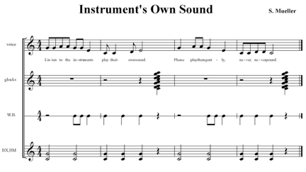
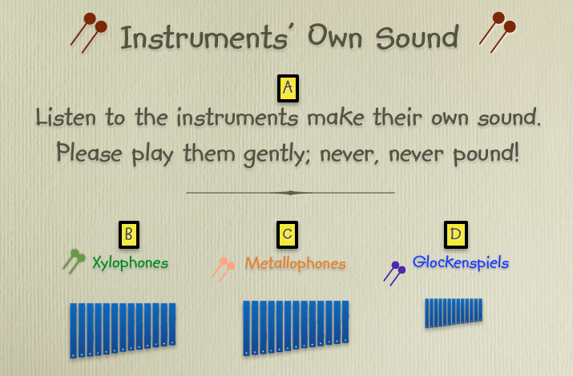

Assessment cards for timbre recognition


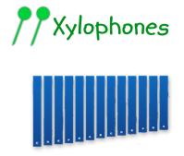

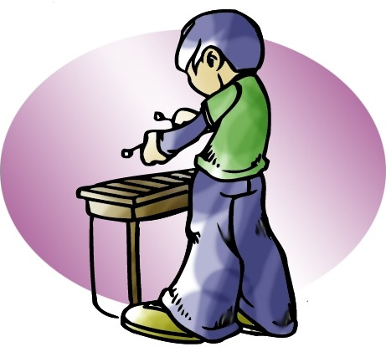

THE ONTOGENESIS OF MELODY

Melody is an outgrowth of speech, with early experiences most likely coming from the 'sing song' quality in play and games. You will want to consider broad concepts such as high/low, up/down, and melodic contour before labeling and creating melodies in a more concrete fashion. The sequence that follows presumes that the child, therefore, has had many experiences with these broad concepts, and begins with the falling minor third - Sol-Mi (Bitonic).

Developing good singers:

When teaching young students, there are those that can match pitch easily, most likely due to the fact that they sing at home and/or have other experiences outside the music classroom that provide opportunity to sing. Some students will have a more difficulty time matching pitch and singing in their head voice. Some thoughts for preparing good singers:

- Teach songs without an external instrument providing the melody.
- Sing without a vibrato
- Teach about breath support and good singing posture
- Avoid phrases such as “sing louder” or “we can’t hear you”; Instead focus the students on diction, articulation and word endings, intonation using gestures.
- If you expect in tune singing and light voices and constantly reinforce this, the students will expect it from themselves.
- Make sure the range of the song is appropriate for the student’s age.
- Chant prepares rhythmic content of singing songs
- Incorporate good listening examples of children’s voices
- Distinguish between high/low
- Discern melodic contour (through movement, hand signs, visual aids, as well as listening)
- Pitch matching games and roll call valuable (repetition needed to succeed)
- Good questioning techniques to focus attention to melody content
- Imitation leading to independent singing
- Be patient and positive, especially with the struggling singer
- Improvise melodic answers
- Give starting pitch, tempo to all songs to promote success
- Remember the voice is in the alto range. Reinforce on alto recorder or alto Xylophone/Metallophone rather than soprano instruments.
- Neutral syllable first to learn melody; words add another challenge and if added to quickly can lead to an inaccurate melody.

BLAH BLAH BLAH ELEMENTARY MUSIC CURRICLUM
Grade: 1 Lesson Sequence No:1

Anticipatory Set:

- No Previous experience needed

Learning Outcomes:

Target Outcome:
- Students will be able to demonstrate the steady beat speaking a rhyme and body percussion.
- Students will speak their name rhythmically
- Students will explore and differentiate between speaking, singing, shouting, and whispering
Other Outcomes:
- Students will explore starting and stopping in reaction to sound/no sound.
- Students will be able to demonstrate explore high/low contrasts,
- Students will discuss the relationship between loud and quiet using speech.

Pre-class Preparation:

- Speak, sing, whisper, shout cards displayed on board.
- Individual packets of voice cards (speak, sing, whisper, shout) ready to distribute.

Vocabulary:
Beat
Rhythm of Words
Loud
Quiet

Sing
Whisper
Shout
Speak

Assessment(s): Verbal, Auditory, Kinesthetic

- Students identify the timbre of their voice according to the 4 voice cards
- Students demonstrate patsching the steady beat.

Note: This is the first music class students have attended Assessment is formative, not summative.  Sequence of Instruction:  - Warm-up: Movement  Music is made up of sound and no sound.  Can you walk when you hear sound and stop when there is no sound?  - Students enter the room walking the pulse matching the quarter note pulse teacher plays on hand drum.  - Students stop walking when drum stops.  - Students continue reacting to the start and stop of the drum, working to start and stop with sound.  - Students are directed to sit in their place as designed by the teacher (rows, circle, teams are possibilities)  - Suggestion: Practice going from one formation to another in an orderly manner.  Start and stop are important for all musicians to understand.  - Speech/Body Percussion: circle formation  Music can have a beat. It also can have no beat.  Keep the beat on your knees to show the beat.  - Teacher models steady beat, patsching and invites students to join when ready  - Teacher speaks the poem while students patsch the beat.  - Students speak the “beat, beat, beat, beat” while patsching, teacher speaks the 2nd and 4th phrases.  - Students echo teacher, speaking 2nd and 4th phrases, each phrase individually  - Students add the 2nd and 4th phrases to the 1st and 3rd phrases without keeping the beat, until secure.  - Students keep the beat and speak the poem, until secure  - Students are directed to explore speaking their name while teacher patsches 2 beats.  Your name has a rhythm. Say your name the way you would when introducing yourself to someone.  - Game:  - Students and teacher speak the poem patsching the beat.  - At end of poem, in order around the circle, each student speaks his/her name, the class echoes. 4 students at a time, returning to the poem after the 4th student.  - Continue in this fashion until all students have taken their turn.  - Voice Timbre:  Do you know how many voices you have? 4!  Speak, whisper, shout, and sing. Let’s make our voices do all 4 of them.  - Teacher and students discuss how many ways to use our voice; speak, sing, whisper, shout.  - Teacher holds up one voice card and speaks the phrase associated with it. Example: “This is my speaking voice, I raise my hand before I talk”. Students echo the phrase.  When and where can you use your speaking voice?  - Teacher continues with all cards until students are secure knowing what to say when a card is shown.  When and where can you use your singing voice?  Note:  - When teacher displays singing voice card, the phrase is sung on Sol and Mi:  S MM SS M SS MM S_____  - When using the shouting voice, students and teacher discuss whether it is loud or quiet, and where and when it is appropriate to use the shout voice  When and where can you use your shouting voice?  - When discussing the whispering voice, students provide where and when it is appropriate to use the whisper voice.  When and where can you use your whisper voice?  - Game: When teacher displays a voice card, student must speak/whisper/shout/sing the appropriate phrase  When I show you a voice card, speak, whisper, shout or sing the phrases I taught you.  - Repertoire Song: “First Day of Music”  Today we are going to end our time together using our speaking and singing voice to learn a song.  - Teacher sings entire song for students, verse 1 only (verse 2 will be added next week, when unpitched instruments are introduced).  - Teacher asks which voice card to show that matches the voice teacher used.  Do you remember how to start and stop? Listen to when I start the song and raise your hand. Raise your hand again when I stop the song.  - Students listen to song again, identifying the beginning of the song by raising their hand.  - Students listen to song again, identifying the end of the song by raising their hand.  Let’s learn the song first by speaking the words. We can practice our whisper and shout voice too.  - Through echo process, students learn the lyrics of song using their speaking voice.  - Repeat using their whisper and shouting voice.  Now let’s use our singing voice. Remember our voice makes high and low sounds.  - Learn the song using their singing voice.  - Formative (informal) Assessment:  - Could the students identify their different voices?  - Could students keep the beat while speaking?  - Was there any student that had difficulty speaking their name rhythmically? | Time Required: 35 minutes
Materials:

Voice Cards
Poem – Rhyme
“Keep the Beat and Say Your Name”
Song
“First Day of Music”
Groupings:

Whole/Individual

Wrap –up:

- How many voices did we use today, what were they?
- What was the difference between the beat and how we said our name?

Alignment:

- What are the students supposed to learn?
- What will be done to promote that learning?
- How will I know when learning has occurred?

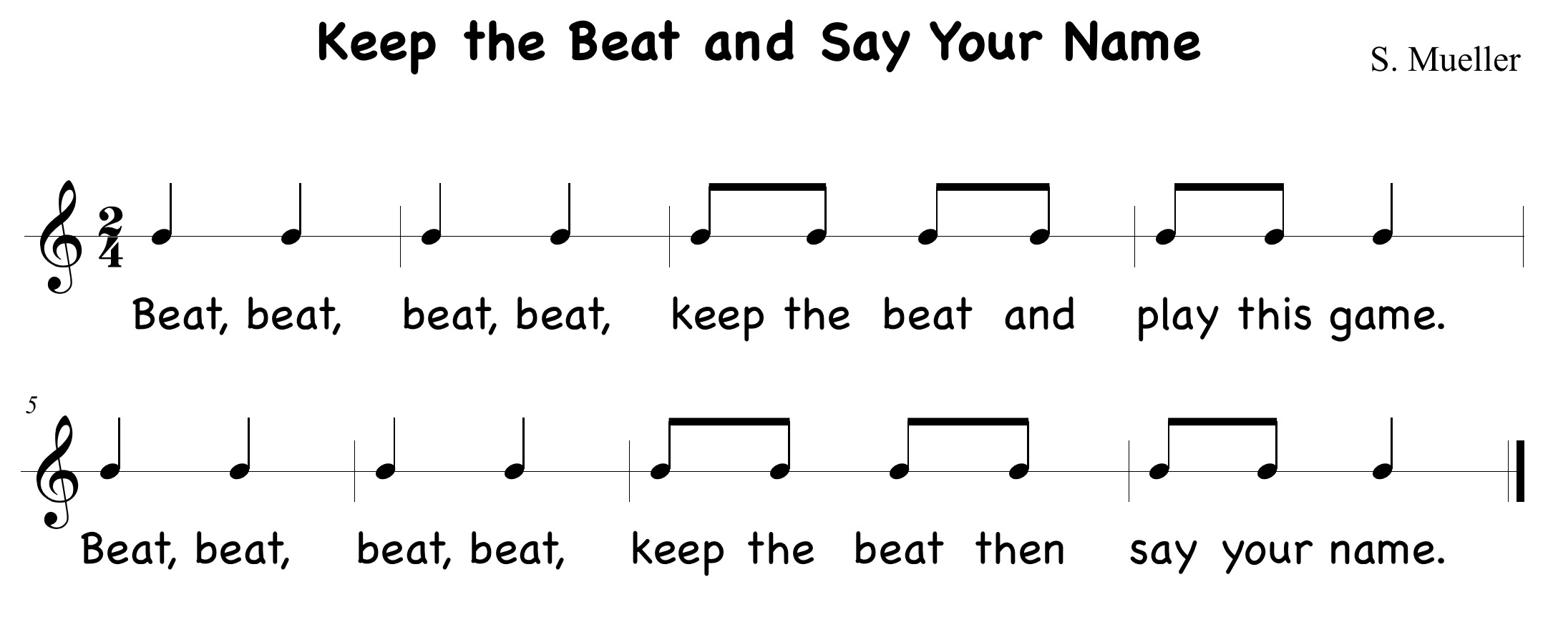
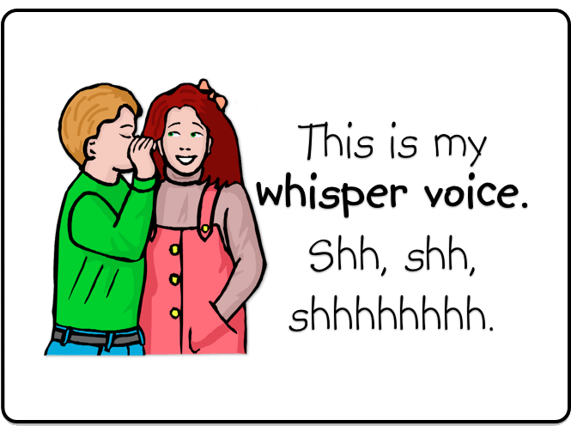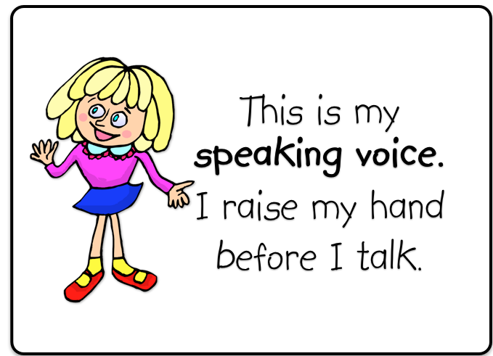
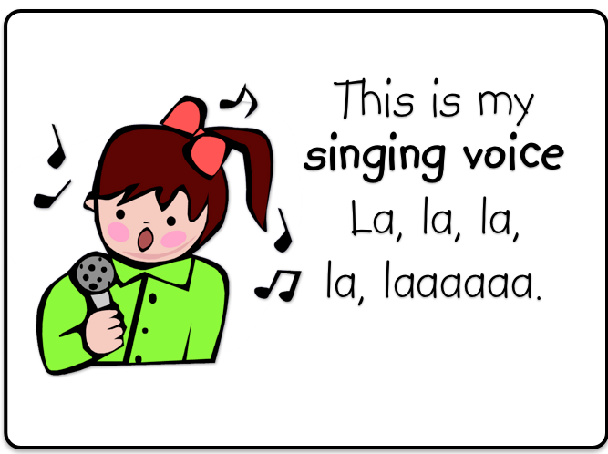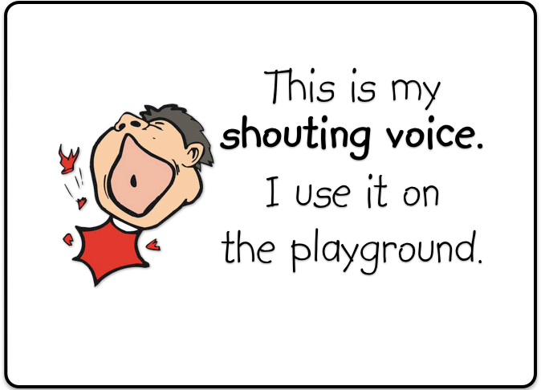
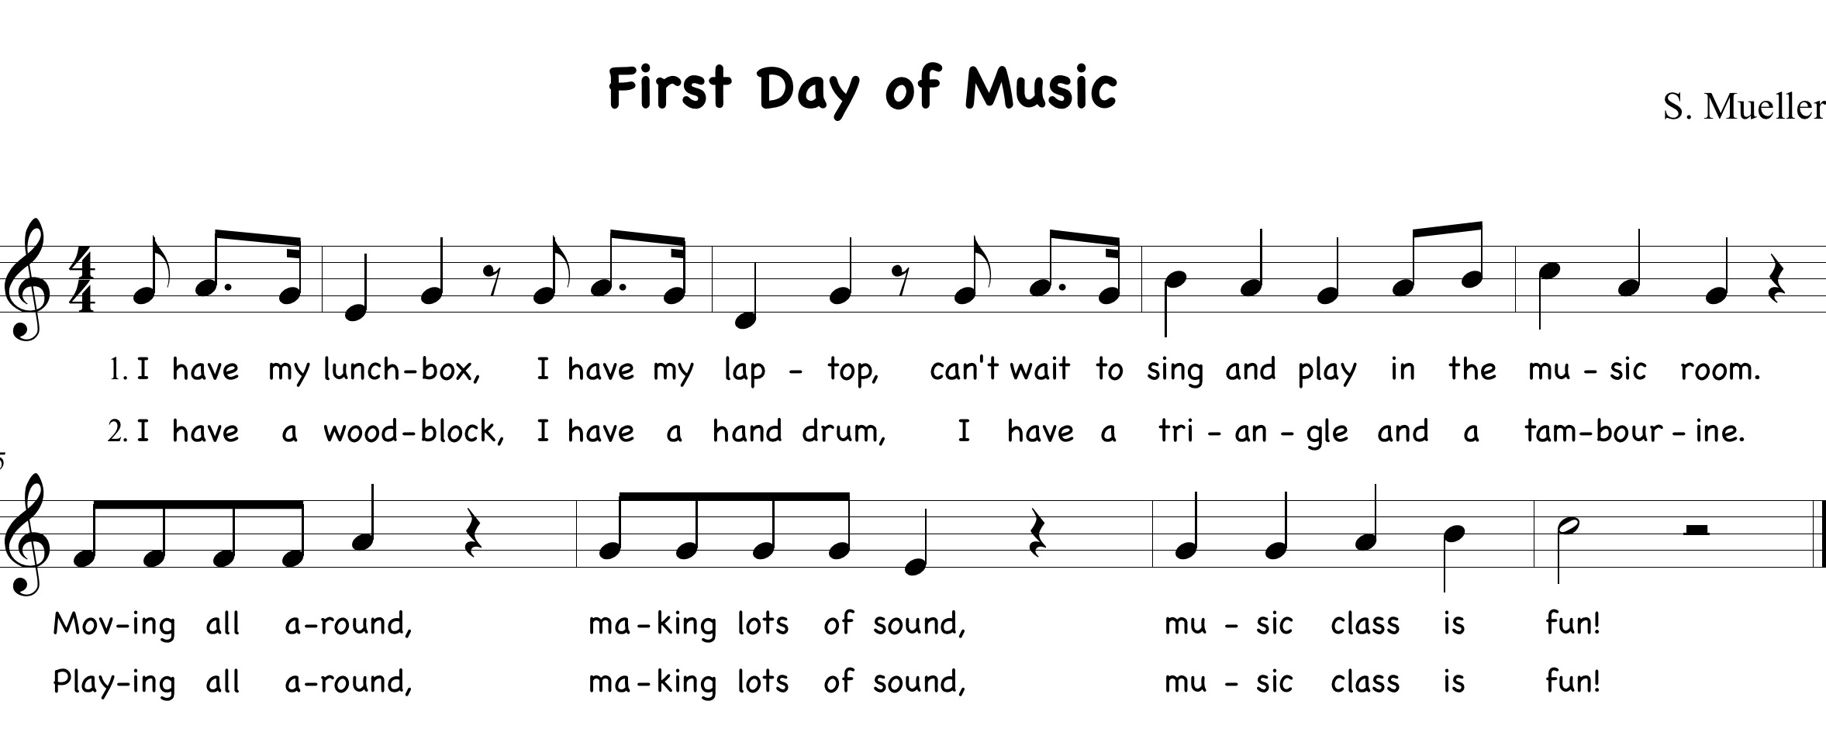

BITONIC

Examples: (Sol- Mi)

Key of C Key of F Key of G Key of D
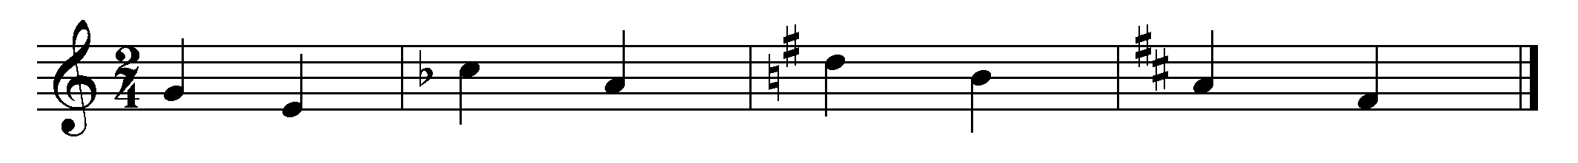

Bitonic melodies are without tension and resemble a chanted call (names, numbers, objects in a group, short phrase…). There is no harmonic implication, (I-V) and should be sing-song in nature and predictable. The simpler the better, even though trained musicians might find them boring.
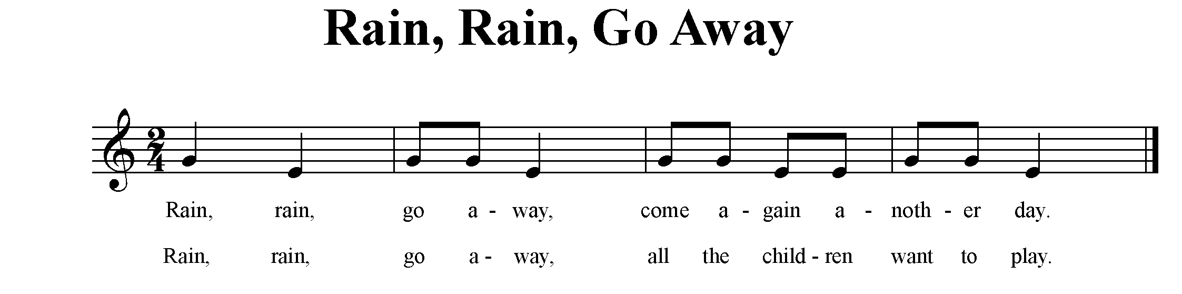
Teaching Sequence:
- Newspaper rainstorm as introduction.
- Prepare sol-mi by patting head for sol, shoulders for mi; (echo teacher)
- Sing song with text, patting head and shoulders (echo teacher)
- Sing song; at the end of song, one student suggests 'what to play' - class pantomimes the play while teacher plays improvisation
- Continue with new suggestions for 'play'.

TRITONIC (Sol-La-Mi)

Examples:
Key of C Key of F Key of G Key of D
Tritonic melodies are again taken from children's playground chants and their own improvisations. There is still no feeling of tonal center or tension in these melodies.

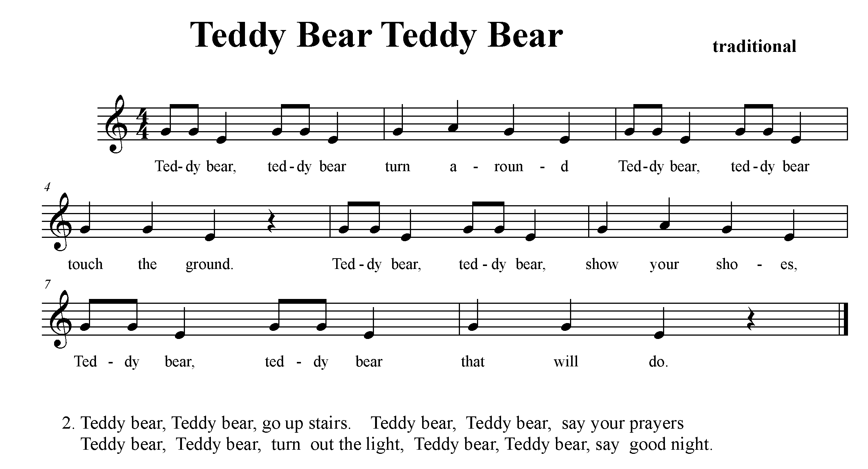

Teaching Sequence:

- Sing with solfege hand signs all "Teddy bears”. Teacher models actions indicated
- Sing again, students imitate teacher's actions
- Patschen, R R L all "Teddy bears”. Transfer to barred instruments.
- Isolate and identify the Sol-Mi fragment for Teddy bear. Present visual. Discuss

IMITATION: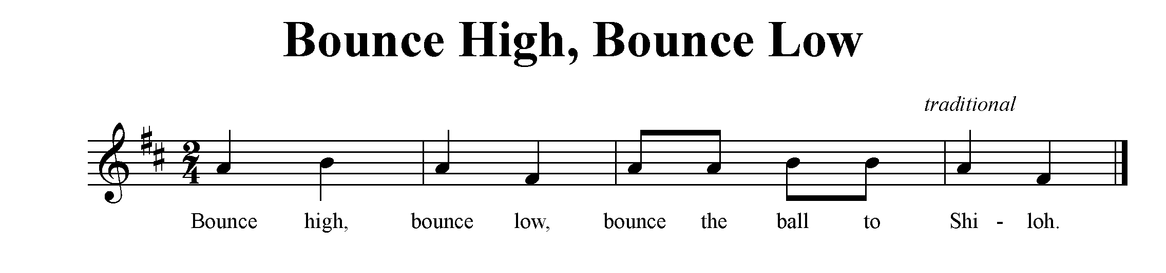
Teaching Sequence:

- Visualize melodic contour with yarn ball or beach ball.
- Students echo teacher as teacher shows melodic contour with ball.
- Echo words and melody until secure.
- Game: In standing circle, pass ball from person to person in drop-catch pattern, ball hitting the floor on accented beats, keeping pulse.
- On another day, students can repeat the game as a review, however, this time substituting the name "Shiloh" with a student’s name, bouncing the ball to that student. That student bounces the ball (solo) before continuing the game.
- Visualize the melodic contour using ball icons to represent the notes.

GAME USING TRITONIC MELODY

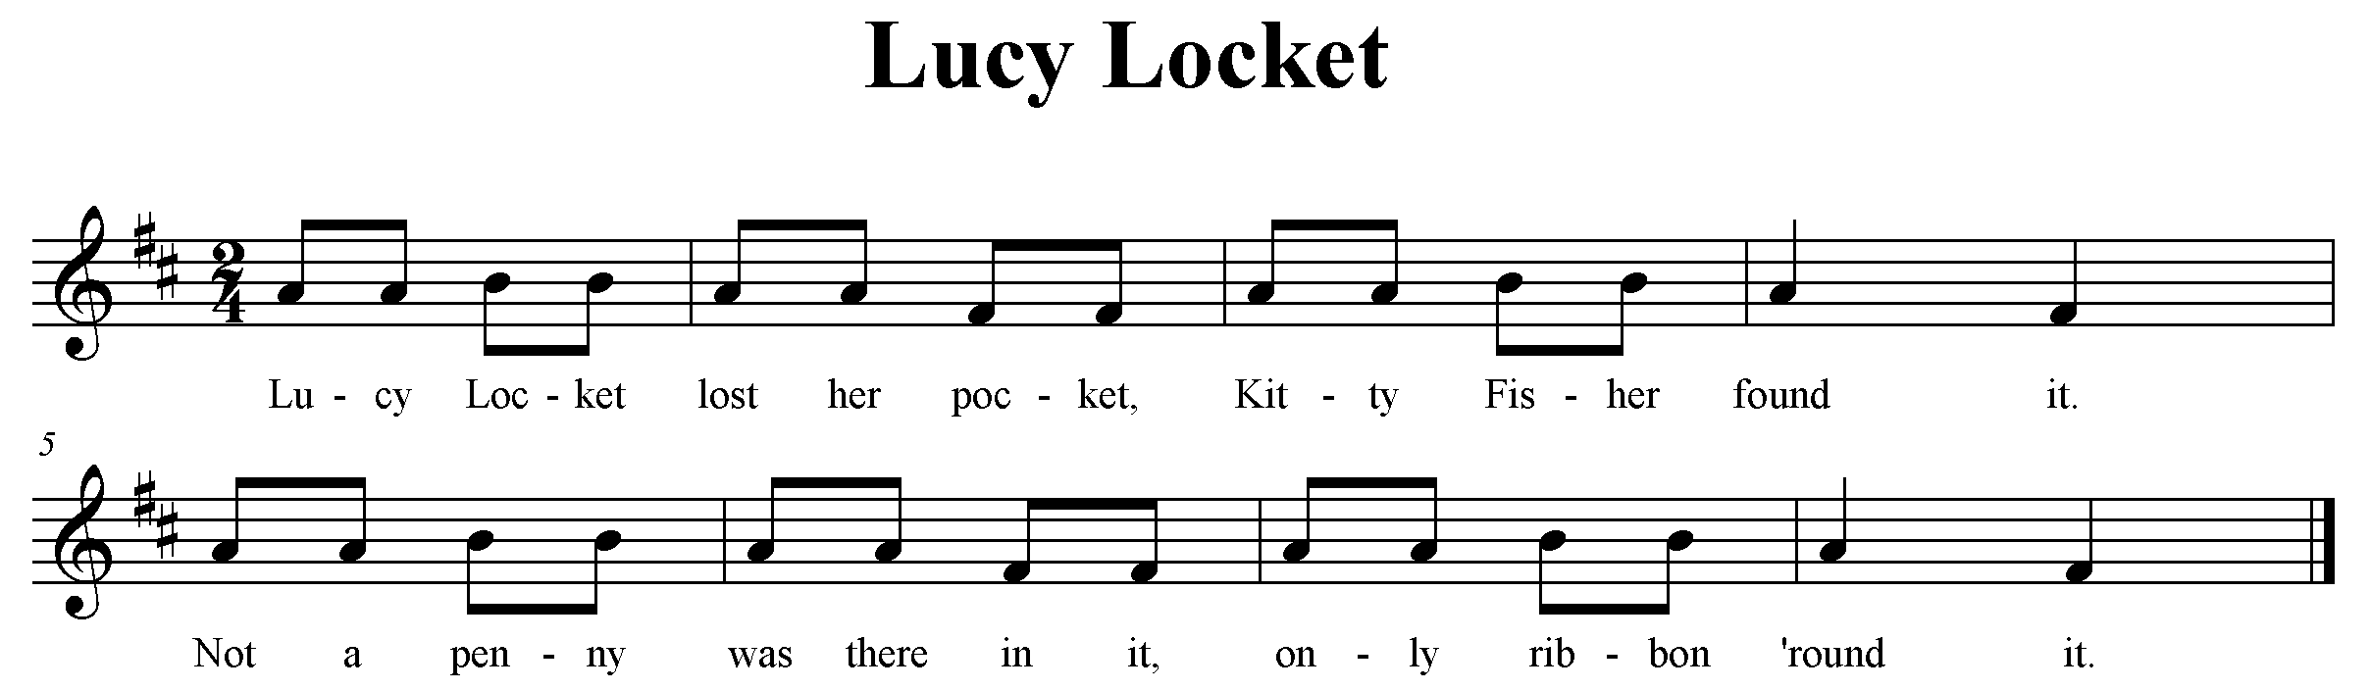

Teaching Sequence:
- Echo song with hand signs, sol- la- mi
- Discuss relationship of la to sol (higher)
- Notice phrase one and two have the same melody but different words
- Sing song using different dynamics, p mf f: make sure that they are still using their singing voice and not their shouting voice.
- Teacher shows class a hidden pocket. (make one out of cardboard or paper…)
- Class sings quietly as teacher is far from pocket, louder as teacher gets nearer
- Patschen pulse, (transfer to barred instruments C and G played simultaneously)
Game: - One student hides eyes, second student hides pocket.
-First student finds pocket, listening to class sing p mf or f according to the proximity of student to pocket
-Each picks someone to take their place and repeat game.
- On a different day, notate sol- mi - la on a two line staff.

____________________________________________________
____________________________________________________ repeat

RHYTHM

IMITATION - 2/4:
- Echo patterns in 2/4, clapping, patsching, snapping and stomping - teacher leads students to discover strong and weak beats leading to experiencing 2/4 meter.

Review classification of instruments into families, pitched and unpitched.
- Woods
- Metals Optional: Shaker /Scrapers can be part of woods, metals
- Membranes or a group of their own.

Sample Lesson

_________________ ELEMENTARY MUSIC CURRICLUM
Grade: 3 Lesson Sequence No:

Anticipatory Set:

- Students have had previous experience with steady beat
- Students have had previous experience playing unpitched percussion instruments
- Students can read rhythms notated using quarter, eighth, half notes, and quarter and half rests.

Learning Outcomes:

Target Outcome:
- Students will be able to demonstrate steady beat, accented, and unaccented
- Students will demonstrate accented and unaccented beats using movement and playing unpitched percussion instruments.

Other Outcomes:
- Students will be able to read rhythms using eighth, quarter notes and quarter rests.
- Students will analyze same/different phrases.

Pre-class Preparation:
- Visual of Pease Porridge Hot with accents and notation.

Vocabulary:
Beat
Phrase
Quarter note
Quarter rest
Unpitched percussion
Accent, unaccented
Introduction
Coda

Assessment(s):
Students will move to and play beats that are accented and unaccented.
Students will notate correctly the poem.

Sequence of Instruction:  - Warm-up:  Welcome back to school. Let’s start by listening to me play the hand drum while you march the beat.  - Teacher plays a quarter note beat on the hand drum while students march the beat.  Now show me by clapping whenever you hear an accented beat (it will be stronger and louder than the other beats).  - Teacher plays a steady beat on the hand drum and at the beginning of every 8 beats, the first one is played louder. Students clap the accented beats.  Now show me the accented beats by clapping and the  unaccented beats by patsching your knees.  - Teacher plays 8-beat phrases, beginning each with an accented beat, followed by unaccented beats, students show through clapping and patsching.  - Teacher continues in this fashion eventually playing a two –beat pattern, or 2/4 meter. Teacher labels this meter for students to understand that in 2/4 meter, each measure of 2 beats begins with an accented beat followed by an unaccented beat.  - Speak:  I have a poem in 2/4 meter that we are going to speak using accented and unaccented beats and words. Please listen to the poem and then speak each phrase after me.  - Teacher speaks entire poem and then students echo back each phrase until entire poem is learned.  Did you hear any words that were accented? (Pease, hot, cold, in the, nine, old). Let’s speak the poem again and clap on all of the accented words. Patschen your knees on the unaccented beat. Pease porridge is like an oatmeal but made with peas.  - Students speak the poem and clap on the identified words above, and patschen on unaccented beats.  Now let’s clap the rhythm of all of the words.  - Students speak the words and clap all of the word rhythms.  Now let’s use quarter and eighth notes and quarter rest to notate the poem.  - Students with the teacher’s help, draws a ta under each porridge bowl. From there, the students determine which bowl of porridge has one, two or no sounds to change to eighth notes and quarter rests.  Let’s add some unpitched percussion on some of the accented words. What instrument should we play on “pease”?; hot, cold, nine, old?  - Divide students into 4 groups, each with the chosen instrument. Students speak poem and play their instrument only on their accented word. (it would be desired to have four different instrument sounds, woods, metals, drums, and shakers or scrapers (tambourine, maracas, guiro, etc.)  - Create:  Why don’t we create an introduction and coda to our poem? Can you make up an 8-beat phrase about pease porridge?  - Students work together in pairs or small groups to create an introduction and coda. Share with class. Students decide which ones they like.  - Perform:  Let’s perform the whole poem with our new introduction and coda. How shall we put this together, including all the ways we learned the poem.  Introduction  Poem, speak words only  Poem, speak and clap word rhythms  Poem, speak and add accented and unaccented beats  using body percussion  Poem, speak and add unpitched percussion instruments on  special words  Poem, without words, just instruments  Coda  - Assessment:  - Formative assessment: teacher observes students playing the beat and playing accented versus unaccented beats.  - Formative assessment: teacher observes whether students can accurately assign quarter and eighth notes and rests to text. | Time Required: 35 minutes
Materials:
“Pease Porridge Hot” poem
Unpitched percussion:
Groupings:

Whole
Small Groups

Wrap –up:

- What is an accented beat?
- What did we call the part of the poem at the very beginning, that you created? (introduction)
- What do we call the part of the poem you created for the end? (coda)

Alignment:

- What are the students supposed to learn?
- What will be done to promote that learning?
- How will I know when learning has occurred?
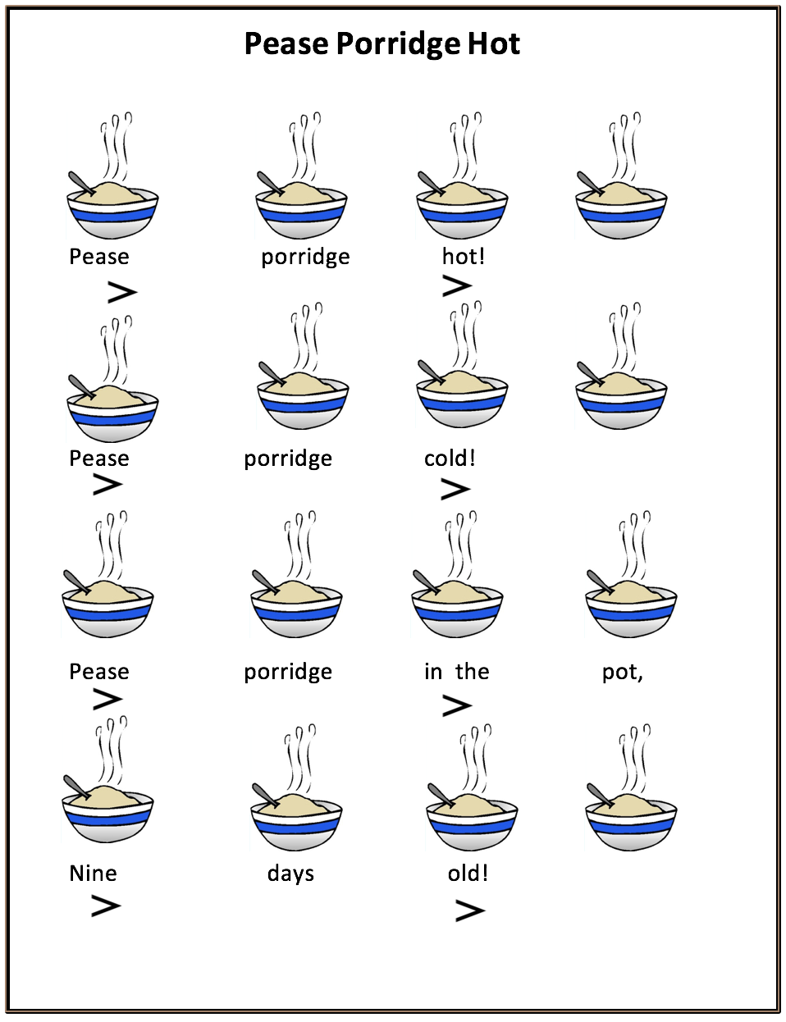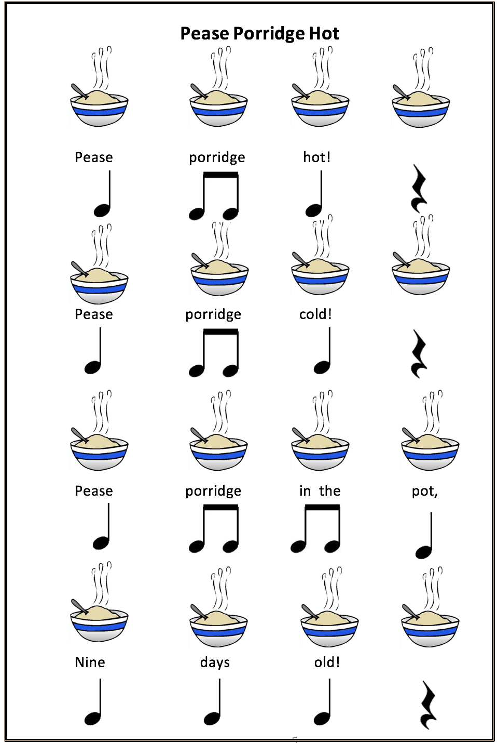

TETRATONIC
In tetratonic, the melody is still centered around Sol - La -Mi, but Do is added,
leading to the triad Do - Mi - Sol.

Examples:
Key of C Key of F Key of G Key of D
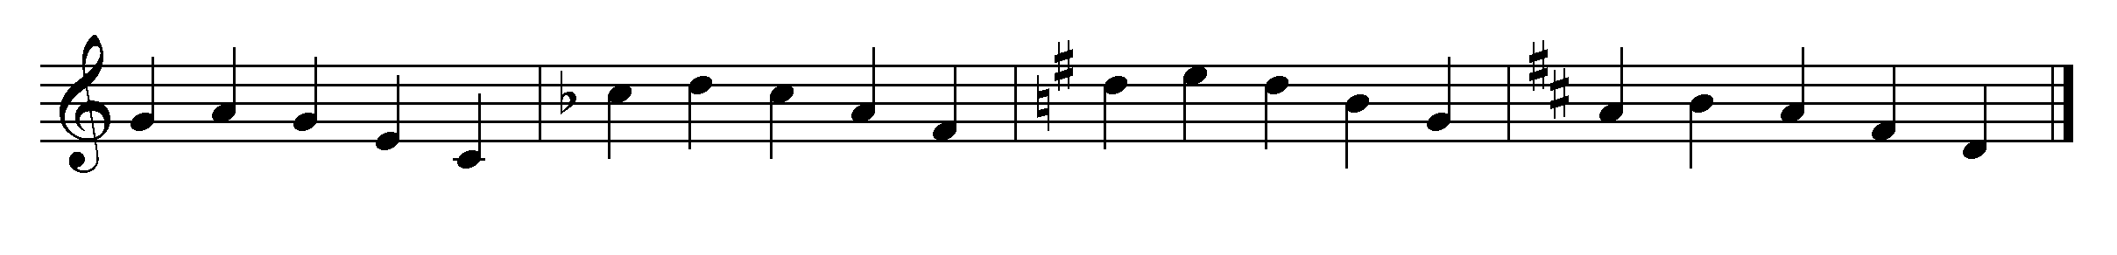

Example: Children’s song- students experience low do in an action song.
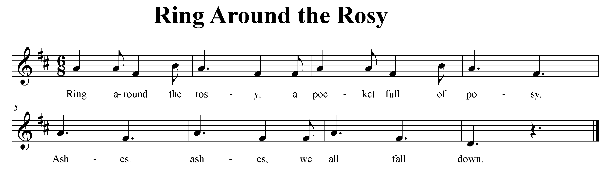
Teaching Sequence:
- Circle game, students sing and walk or skip forward in a circle. On low do -fall down.
- Fun to do with a parachute

Example: Mi-Do-Mi-Sol- through a hand game.
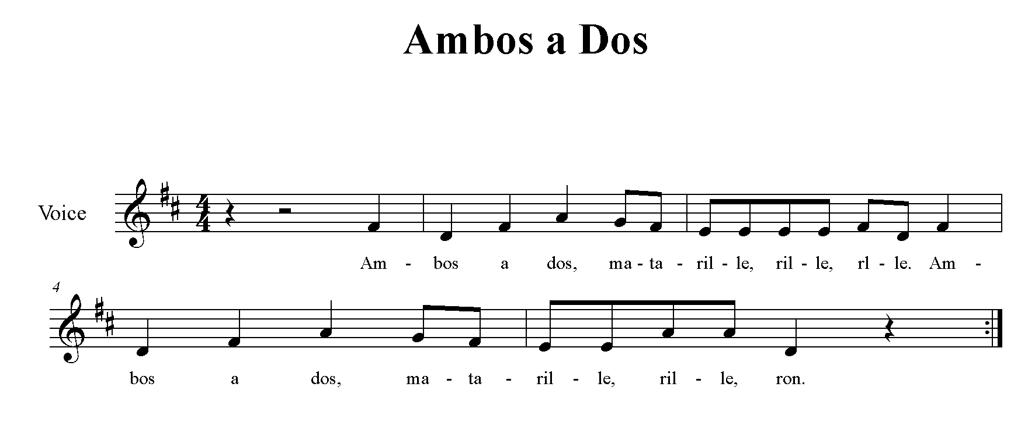
Teaching Sequence:
Echo with hand solfege hand signs, Mi- Do - Mi - sol
Teach hand game without drum.
- Mi partners hold left hands and tap own wrist
- Do partners still holding left hands, tap partner's right hand under held hands
- Sol partners still holding left hands, tap right hands above held hands
When using a drum, partners hold drum instead of each others hand
- Matarille turn small 1/2 circle, taking 4 steps
- Ron tap each other's head
Extend game by having the participants internalize 1, 2 and finally all of the words

- Internalize Sol 6. Internalize Mi, Sol and Do
- Internalize Do 7. Internalize above and Matarille, rille, rille
- Internalize Mi 8. Internalize above and Ron
- Internalize Mi and Do 9. Sing entire song, all words in, fermata on
- Internalize Mi and Sol last note;(singers choose last pitch)

- Further Extension: Students create the beginning of the song, manipulating the first four pitches (still using Sol-Mi-Do) and share with class.
- Students notate first four pitches.

HARMONY

THE SIMPLE BORDUN
A bordun is a single chord accompaniment based on the first and fifth scale degrees.
It indicates an awareness of tonality. It is a drone accompaniment, meaning inactivity or non-working. We use it to provide a stable, tonic accompaniment. In the 10th -14th century the hurdy-gurdy often played both accompaniment and melody.
A hurdy-gurdy (or vielle-á-roue in French) is a bowed stringed musical instrument. It usually has one or two melody strings, and two or more drone strings. Thus the word drone or bordun.

Below are the four basic simple borduns.
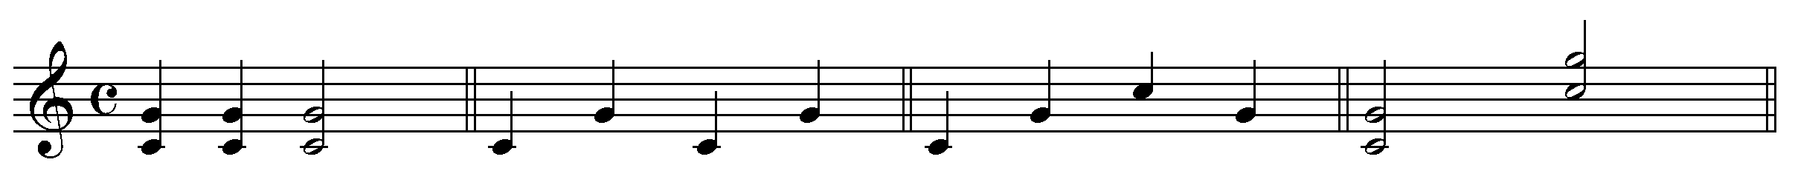
CHORD BROKEN CROSSOVER LEVEL

The following rules apply when determining whether or not to use a bordun;

- You may use a bordun with a melody that has any combination of notes from the pentatonic scale.
- You may use a bordun with a diatonic melody that does not have FA or TI
falling on the strong beats as you will hear the implication of a dominant chord
change.

The bordun sounds below the melody and is usually scored for low pitched instruments such as the Bass Xylophone/Metallophone. It must sound on every strong beat.

2/4 - strong beat is on beat 1 4/4 - strong beat is on beat 1 and 3

6/8 - strong beat is on beat 1 3/4 - strong beat is on beat 1 and 3

When using the bordun, make sure that the interval of a fifth is not altered
(an octave and a fifth is not acceptable). The keys of C, D are most likely to need the tonic pitch doubled at the octave.
The tonic of the chord is played with the left hand, and will always be the lower of the two pitches (tonic and dominant) while the dominant is played with the right hand.
A Bordun is a tonic chord accompaniment. An accompaniment that changes chords, therefore, cannot be referred to as a bordun.

Example - Chord Bordun, lower primary grades; S -M- L melody; color added

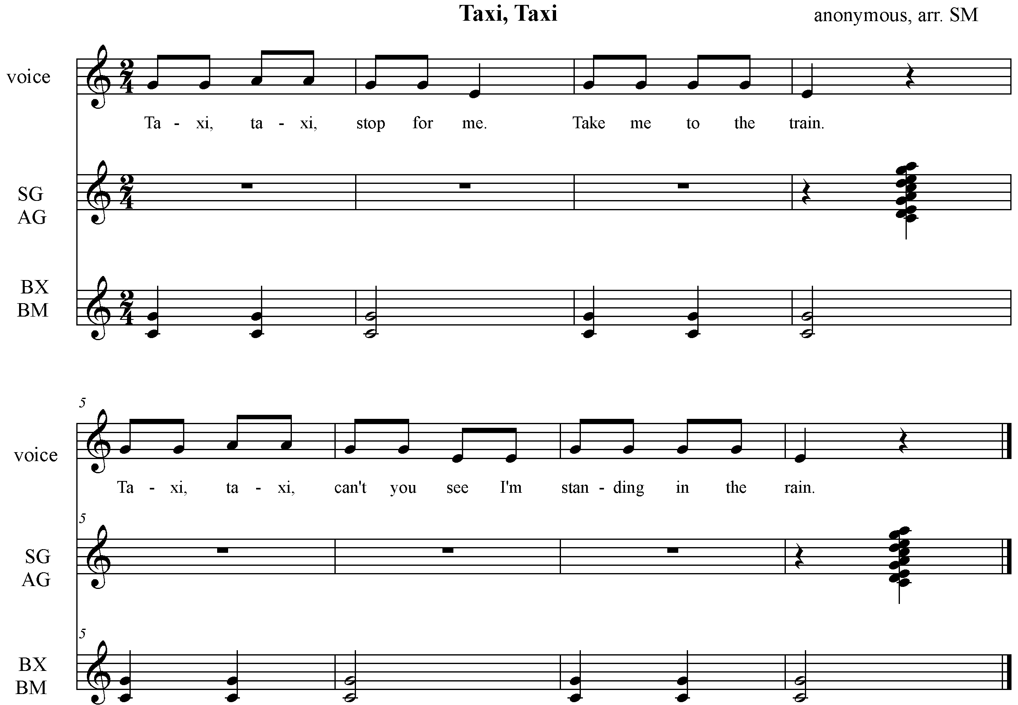

Teaching Sequence:

- Echo melody, S -M - L; refine to melody of song
- Add text; patschen pulse and sing song
- Snap after rhyming words "train" and "rain";
- Transfer pulse to bordun, snaps to glockenspiels on any two notes of pentaton
Game: Scattered formation: Half on instruments.
- One student is selected as taxi driver.
- He/she walks about the room and at end of the song, 'picks up' a child (new fare).
- New fare gets behind the taxi driver and follows, picking up more children on the song's repetition.
- After all have been picked up, taxi driver delivers them to the instruments and the students change jobs, (instrument players returning to a scattered formation with a new taxi driver.)
- Repeat above game.
- Try adding a taxi horn at the end of the song, signaling the student to get on board the taxi!

Example - Chord Bordun upper grades: (more difficult rhythmic structure) 22

- Echo syncopated rhythms; Refine to rhythm of BX, BM
- Echo teach song by phrase. Divide; Teacher-verse, students-refrain; Switch jobs
- Orchestrate through body percussion
- Combine all parts and sing; Add verses when secure with first verse
- Create movement at class suggestion

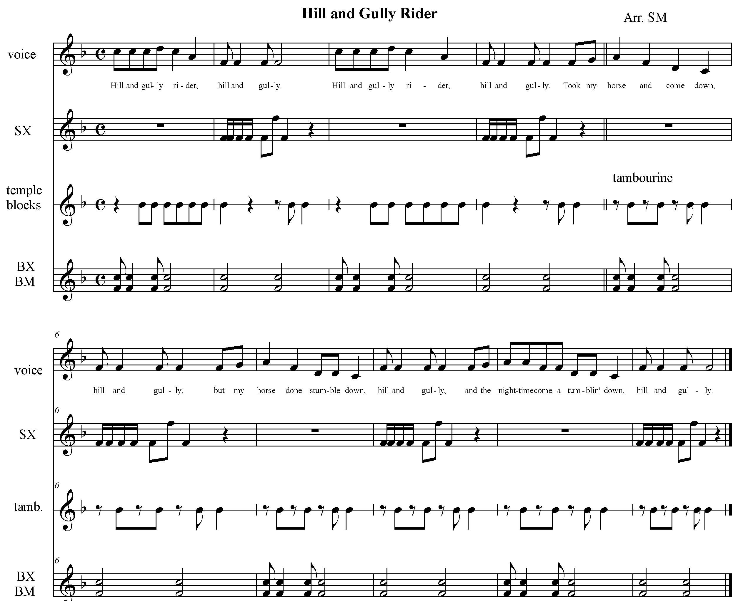

- Oh, the moon shines bright
down,...
Ain't no place to hid 'm down,....
An' a zombie come a-ridin'
down,....

Refrain

3. Oh, my knees they shake down,…

An' my heart strings start
quakin',…

Ain' nobody goin' to get me
down,…

Refrain

4. That's the last I sit down, …

Pray the Lord don' let me
down,

Ain' nobody goin' to get me
down,...

Refrain

Singing game: 6/8 meter, pulse activity. This meter is much easier for children to understand through movement first, rather than trying to sub divide and visualize it from the beginning. 6/8 meter is felt in two, a duple meter, through skipping, galloping, and sliding. Many nursery rhymes are in this meter and all are appropriate for the primary aged child.

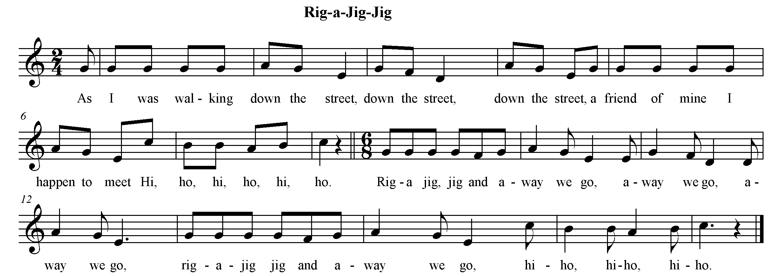

Teaching Sequence:
- Echo melody by phrase
- Add movement
- Walk the verse and sing, finding "a friend of mine" by the end
- With partner, "rig-a-jig-jig" it by using see-saw motion, hands held, and then skip with partner on "away we go…"
- Add new "rig-a-jig-jig" motions and make it cumulative throughout the rest of the game.

Suggestions:
- See-saw (rhythm of words)
- Patschen
- Stamp
- Wiggle hips

OSTINATO

Ostinato, ostinato.
What are you? What are you?
I'm a little pattern, I'm a little pattern.
Stubborn too! Stubborn too!

- The ostinato is a pattern, which repeats itself at least one time. It may be rhythmic, melodic, or harmonic and may be used in speech, singing, playing of instruments, in movement or body percussion.
- Because it repeats, it is a form that can be very successful for children and can develop a simple poem, rhyme or song to quite a degree of complexity. It is one the Schulwerk's most useful tools.
- The ostinato gives immediate results, develops memory, pulse, coordination and group cohesion.
- The ostinato should be complementary to the text or melodic rhythm, never mirroring either in total.

We will explore the ostinato in speech/singing, movement, body percussion and unpitched percussion, using one and two ostinati against a poem, melody and layered together.

Example - Pulse Ostinato
The easiest kind of ostinato, introduced to young children through poems, rhyme games and songs, will reinforce the steady beat.

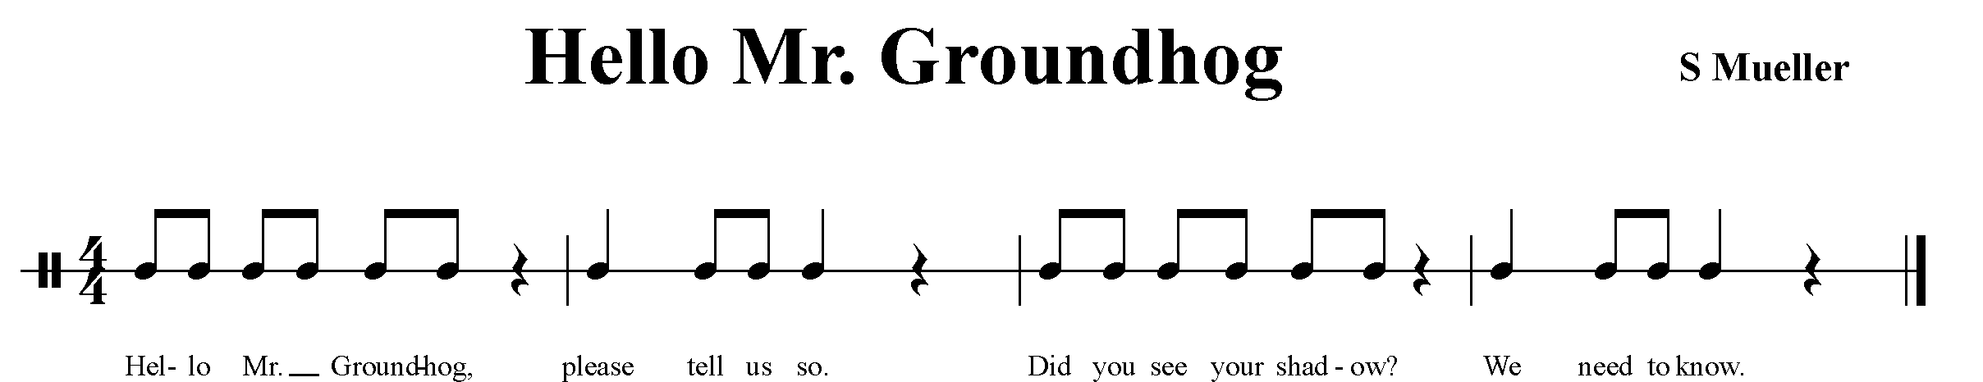
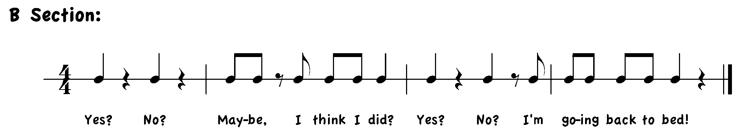
Teaching Sequence:
- Keep pulse on knees, saying poem. Learn one phrase at a time
- Imitate body percussion pulse, two, three, then four levels. (as class is able)
- Repeat poem with ostinato.

Speech Ostinato Example - Developing an ostinato from a poem or rhyme usually includes words contained in that poem or rhyme. The trick is to make it complementary! Try to avoid like rhythmic content rhythm of the ostinato with that of the poem / rhyme.
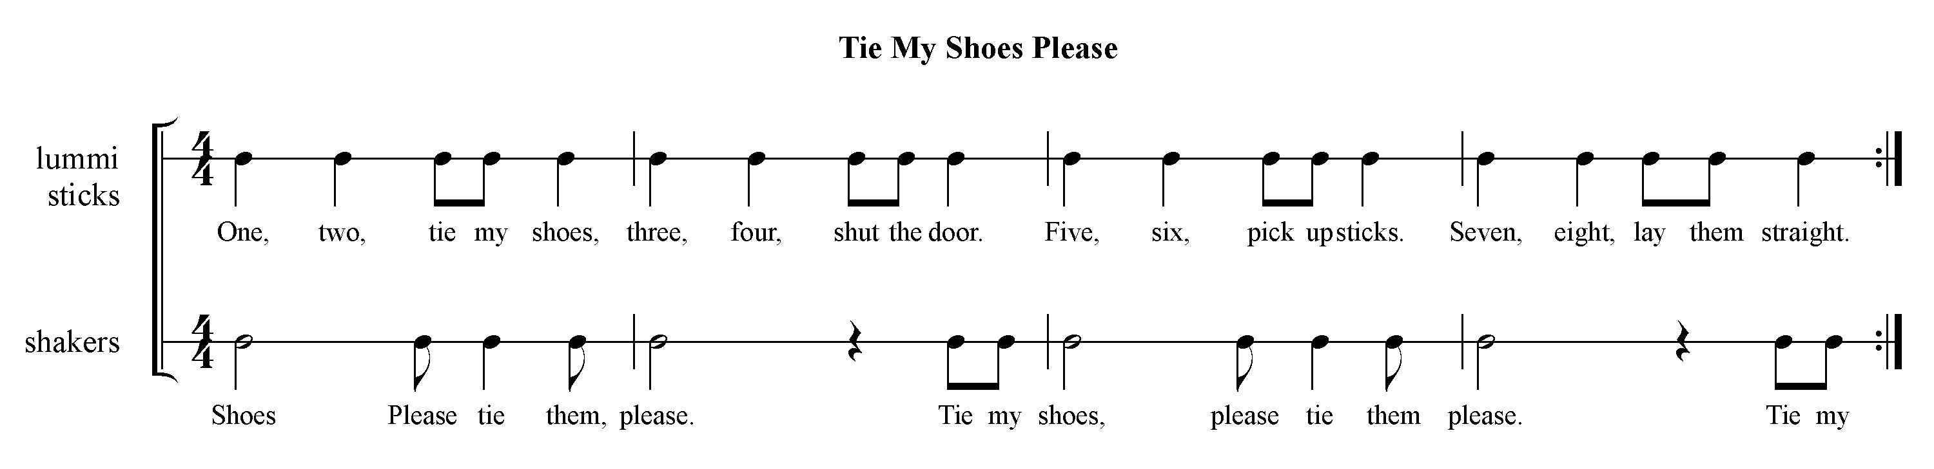

Teaching Sequence:
- Echo poem by phrase, keeping pulse *Extension: Put poem on lummi sticks
- Teach ostinato Ostinato on metals or
- Perform both, dividing class into two parts Shaker / scrapers

Split Ostinato Example

A split ostinato is easily done by dividing one ostinato into two (2) different sounds-body percussion, unpitched percussion, movement, speech.

- Try dividing your name or a famous person's name into two levels of speech
( high /low, loud/soft, vocal sounds ("ch" "fft")
- Divide between two levels of body percussion; unpitched percussion
- Select unpitched for the ostinato and improvise over it (Recorder? Hand drum?)

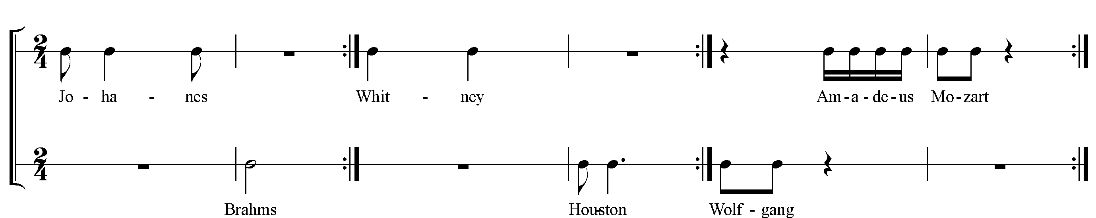

Before completing the pentatonic scale, we connect the Mi. and the Do by using Re. 'Folkloric' melodies are quite prevalent in many cultures and because they are easy to sing and play (stepwise motion) they are successful in the classroom, too.

FOLKLORIC ( Mi-Re-Do )

Examples:
Key of C Key of F Key of G Key of D
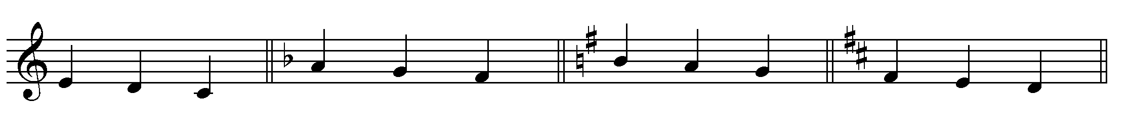

EXAMPLE – FOLKLORIC
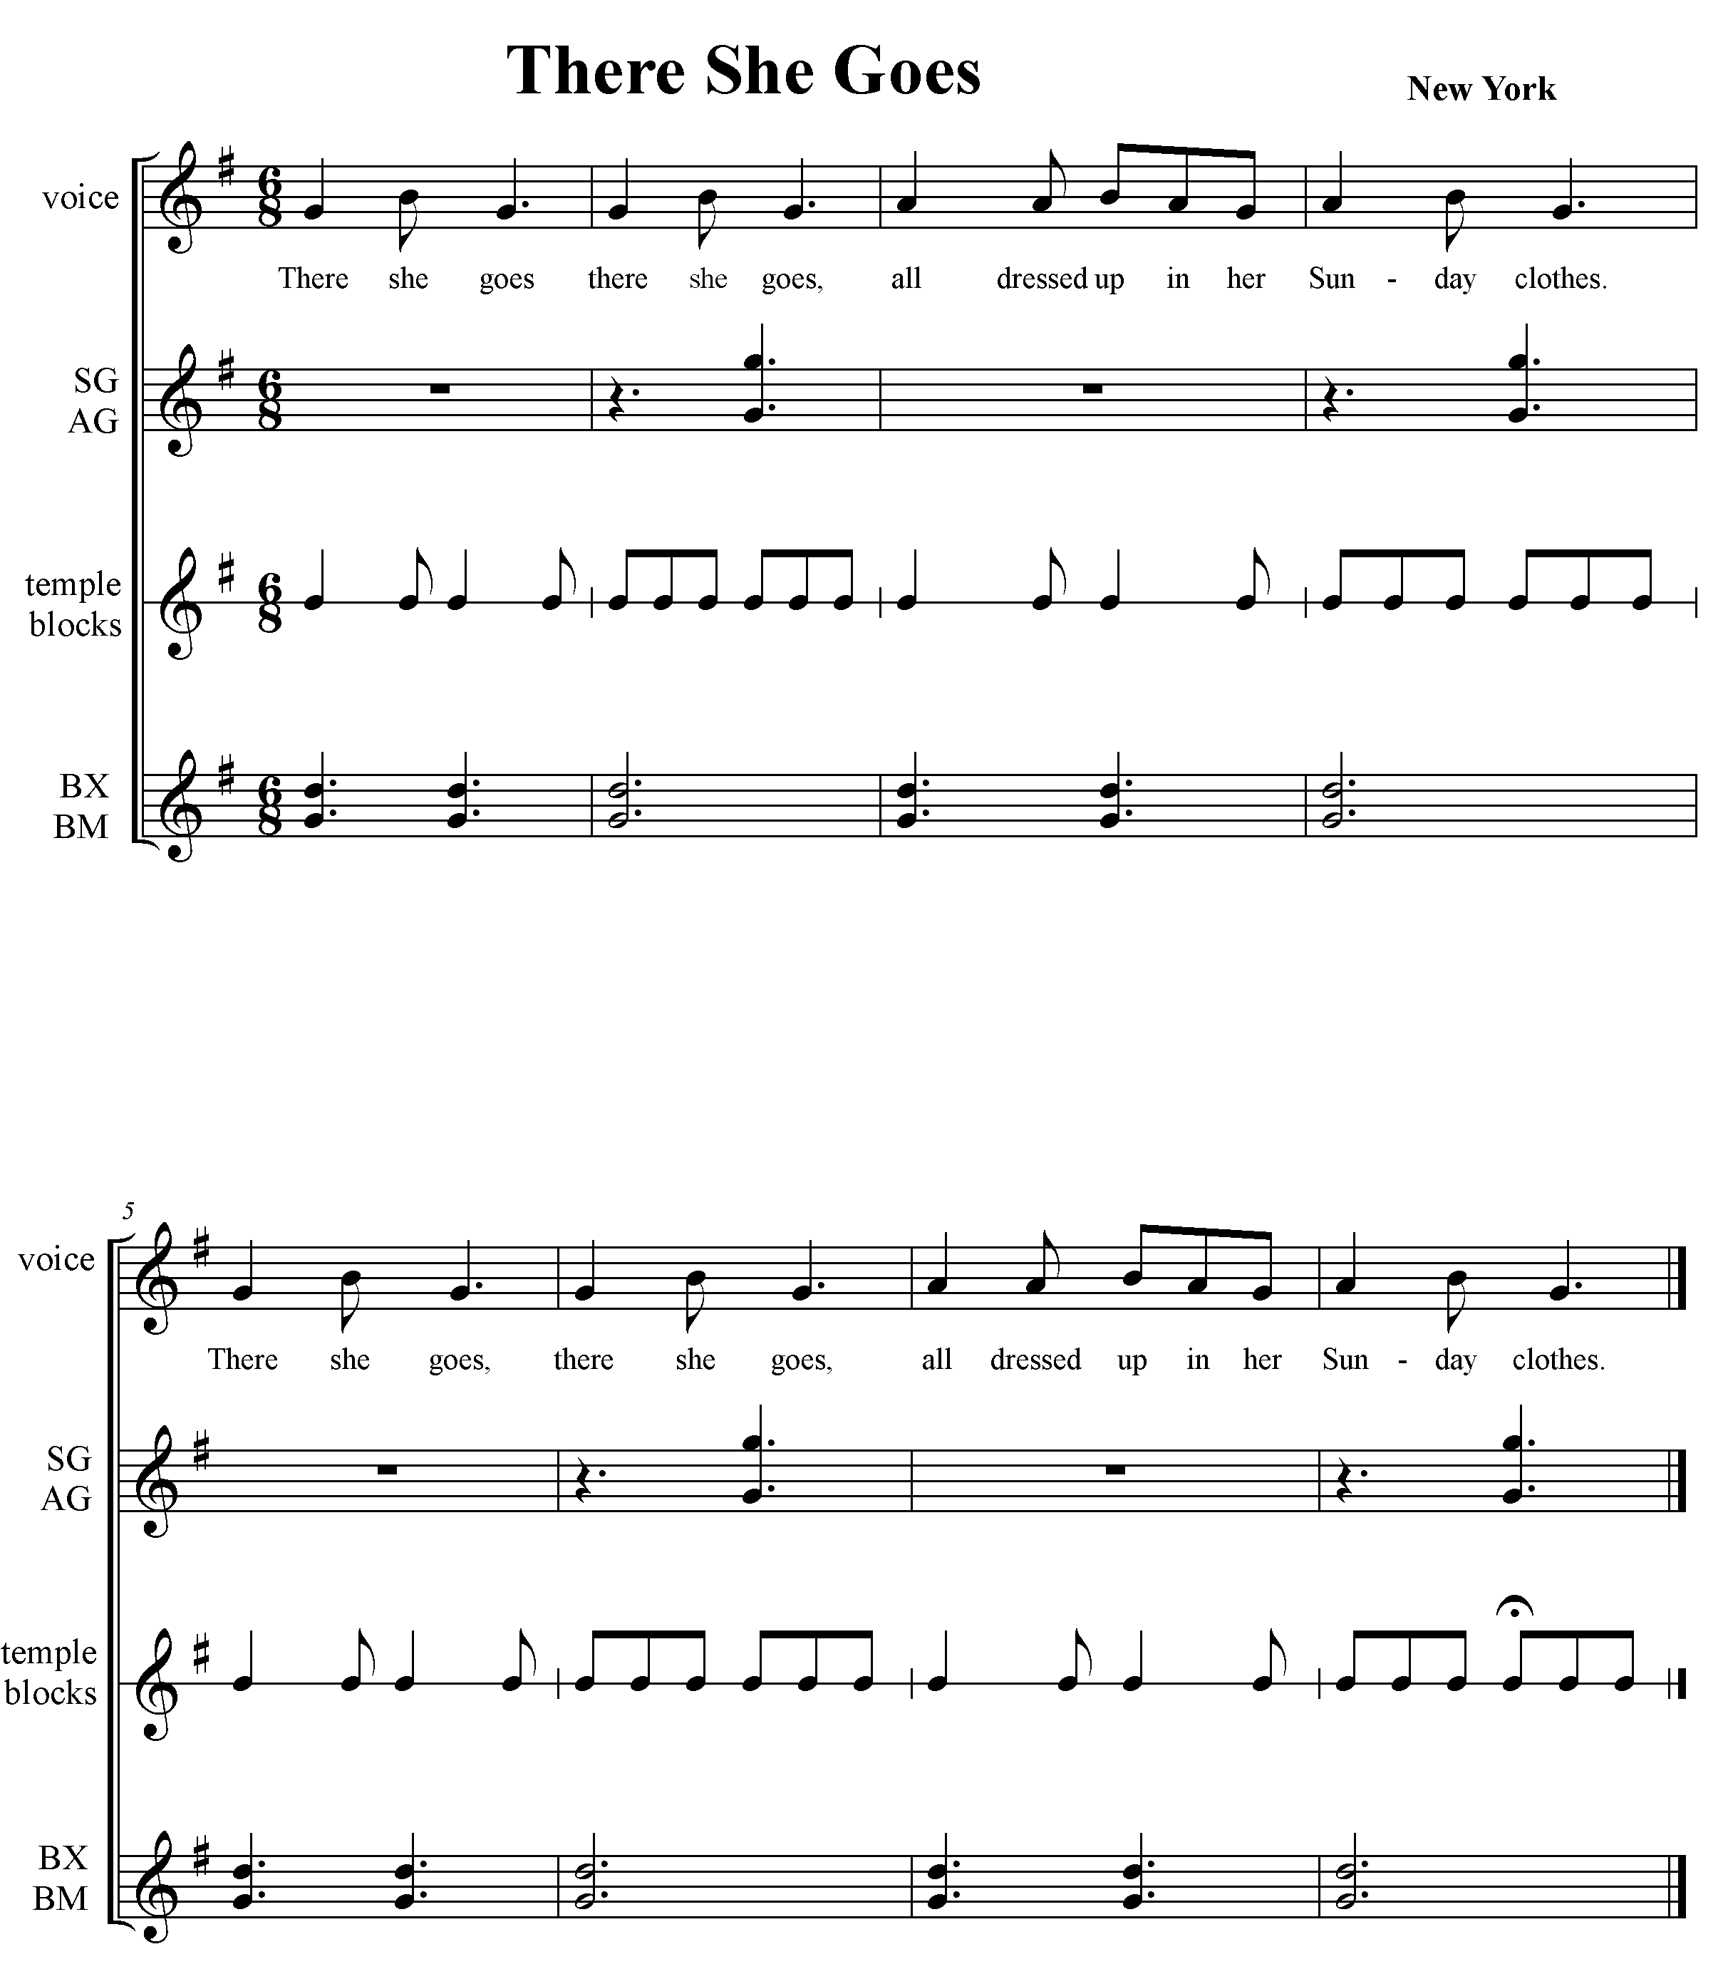
Teaching Sequence:

- Prepare students by walking pulse pretending to be dressed up in:
- High heels, formal dress
- Cowboy outfit, boots
- Clown costume-big shoes
- King of Queen in robe and crown
- Like dad or mom, teacher, grandma…
- Baby

- Teach song, keeping pulse; orchestrate through body percussion
- Students in alley formation: One student who has already chosen a way to walk,
(and costume if wanted), walks down center of isle on first time through song
- Students on either side of alley, walk away from their line and back in the same manner on the repetition of song.

THE BROKEN BORDUN - Like the simple chord bordun, the tonic and dominant of the key are played, however, alternating hands. It is more of a challenge for the student as the tonic must be played on the strong beats, and with the left hand. As in all left / right hand coordination activities, prepare it well through body percussion first, Remember, you most likely will be mirroring this for the children (your right-left).

Broken Bordun to accompany a folk song; primary game

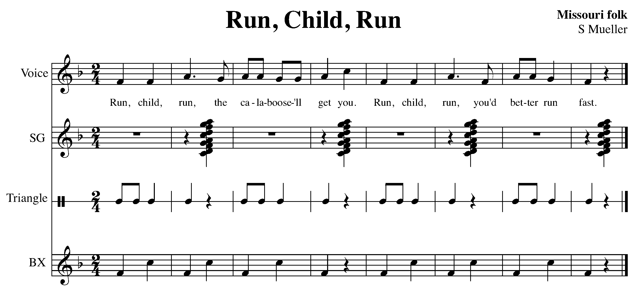
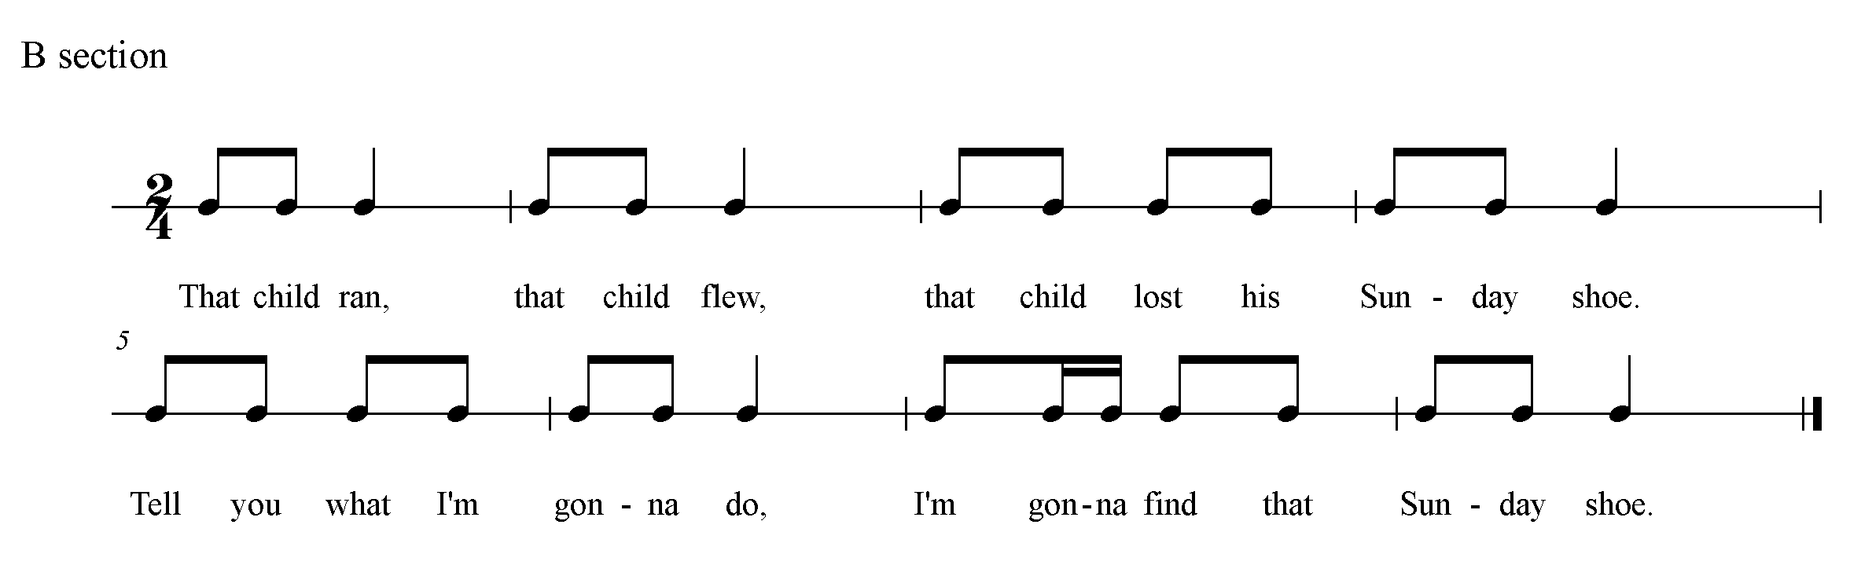

- As an extension, try repeating the song twice. First time the broken bordun is played with s, the second time with s (as if running to find shoe).
Warm-up: Walk , jog
Echo song -words, melody
Patschen and sing song; Patschen and sing song.
Transfer to instruments and then play game: While reciting poem, 1 child walks around outside of seated circle, and 'loses' Sunday shoe by dropping it behind one person by end of song. That child runs after first child, trying to catch him before he reaches ‘ home’.

PENTATONIC - Once students have experienced 2, 3 and 4-note melodies (Bitonic, Tritonic and Tetratonic) they are ready for the full 5-note scale, the pentatonic scale. The pentatonic scale is absent of half steps, only whole steps. D R M S L.

There are a plethora of folk songs in pentatonic scales and these are valuable resources with which to teach children music. The reasons are many.

- No harmonic changes, as removing the half steps eliminates the tension.
- ALL pentatonic melodies may be accompanied with a bordun.
- The lack of dissonance allows all notes to sound together, providing many opportunities for creativity and improvisation. (removing the half steps removes the "mistakes")
- Cultures throughout the world have a rich heritage of pentatonic melodies. Introducing students to world music this way is exciting.

On the barred instruments we use, there are three true major pentatonic scales.

Key of C Key of F Key of G
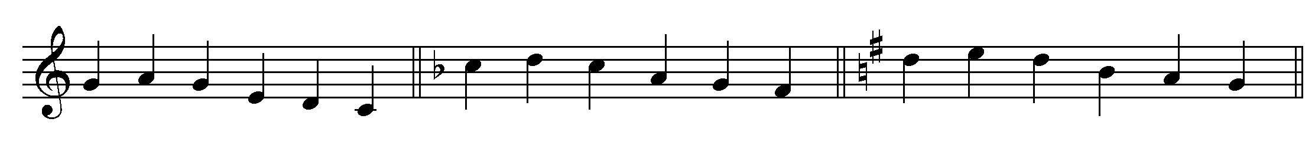
Each of these pentatons may have a tonal center on Do or La, and even Re and Sol. The notes used are the same, but the tonal center may change.

= Do based tonal center

= La based tonal center

C

G
C D E G A C D E G A

D E G A B D E G A

F
C D F G A C D F G A

CROSSOVER BORDUN

The following orchestration is an example of the crossover bordun, introduced after the student has much practice with alternating the left and right hand when playing and after the beat is secure. It must also be noted that this particular form of the bordun crosses the mid-line of the child’s body and is not often easy because of that.

Example – Crossover Bordun- Introducing with a book, Jump Frog Jump

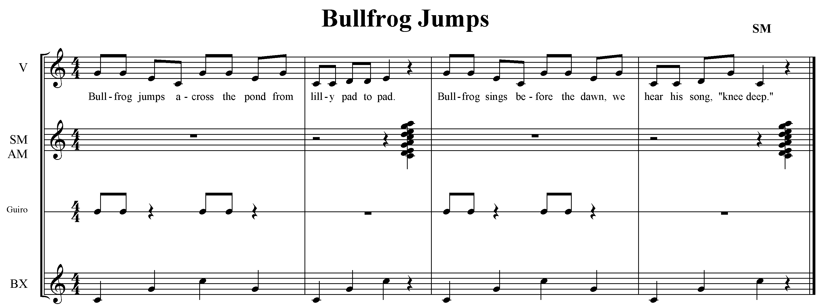

Teaching Sequence:
Read book, Jump Frog Jump by Robert Kalan, Mulberry Books.
- Teach crossover bordun through mirroring
- Play crossover bordun each page turn while T reads book
- Orchestrate song through body percussion
Game: With class seated scattered formation, each student sitting on a lily pad rhythm,
Toss (gently) bullfrog puppet to half note pulse while singing song. Student with puppet at the end of song holds up lily pad and class claps rhythm 4 times.

= glumph

Lily pad
= “knee-deep”

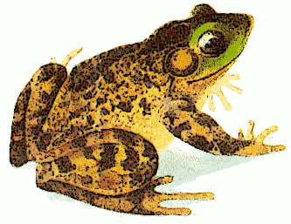

LEVEL BORDUN: The level bordun is still a simple bordun, actually a chord bordun sounding in different octaves. The level bordun, then sounds at different high and low levels. It may be divided between two or more instruments, thus providing the challenge. The students must play their part, all the while knowing where it fits in with the other parts. The strong beats of the level bordun should still sound below the melody. It is wise to really prepare the parts well with body percussion before approaching the instruments.

Example: Level bordun F (3 levels of sound )

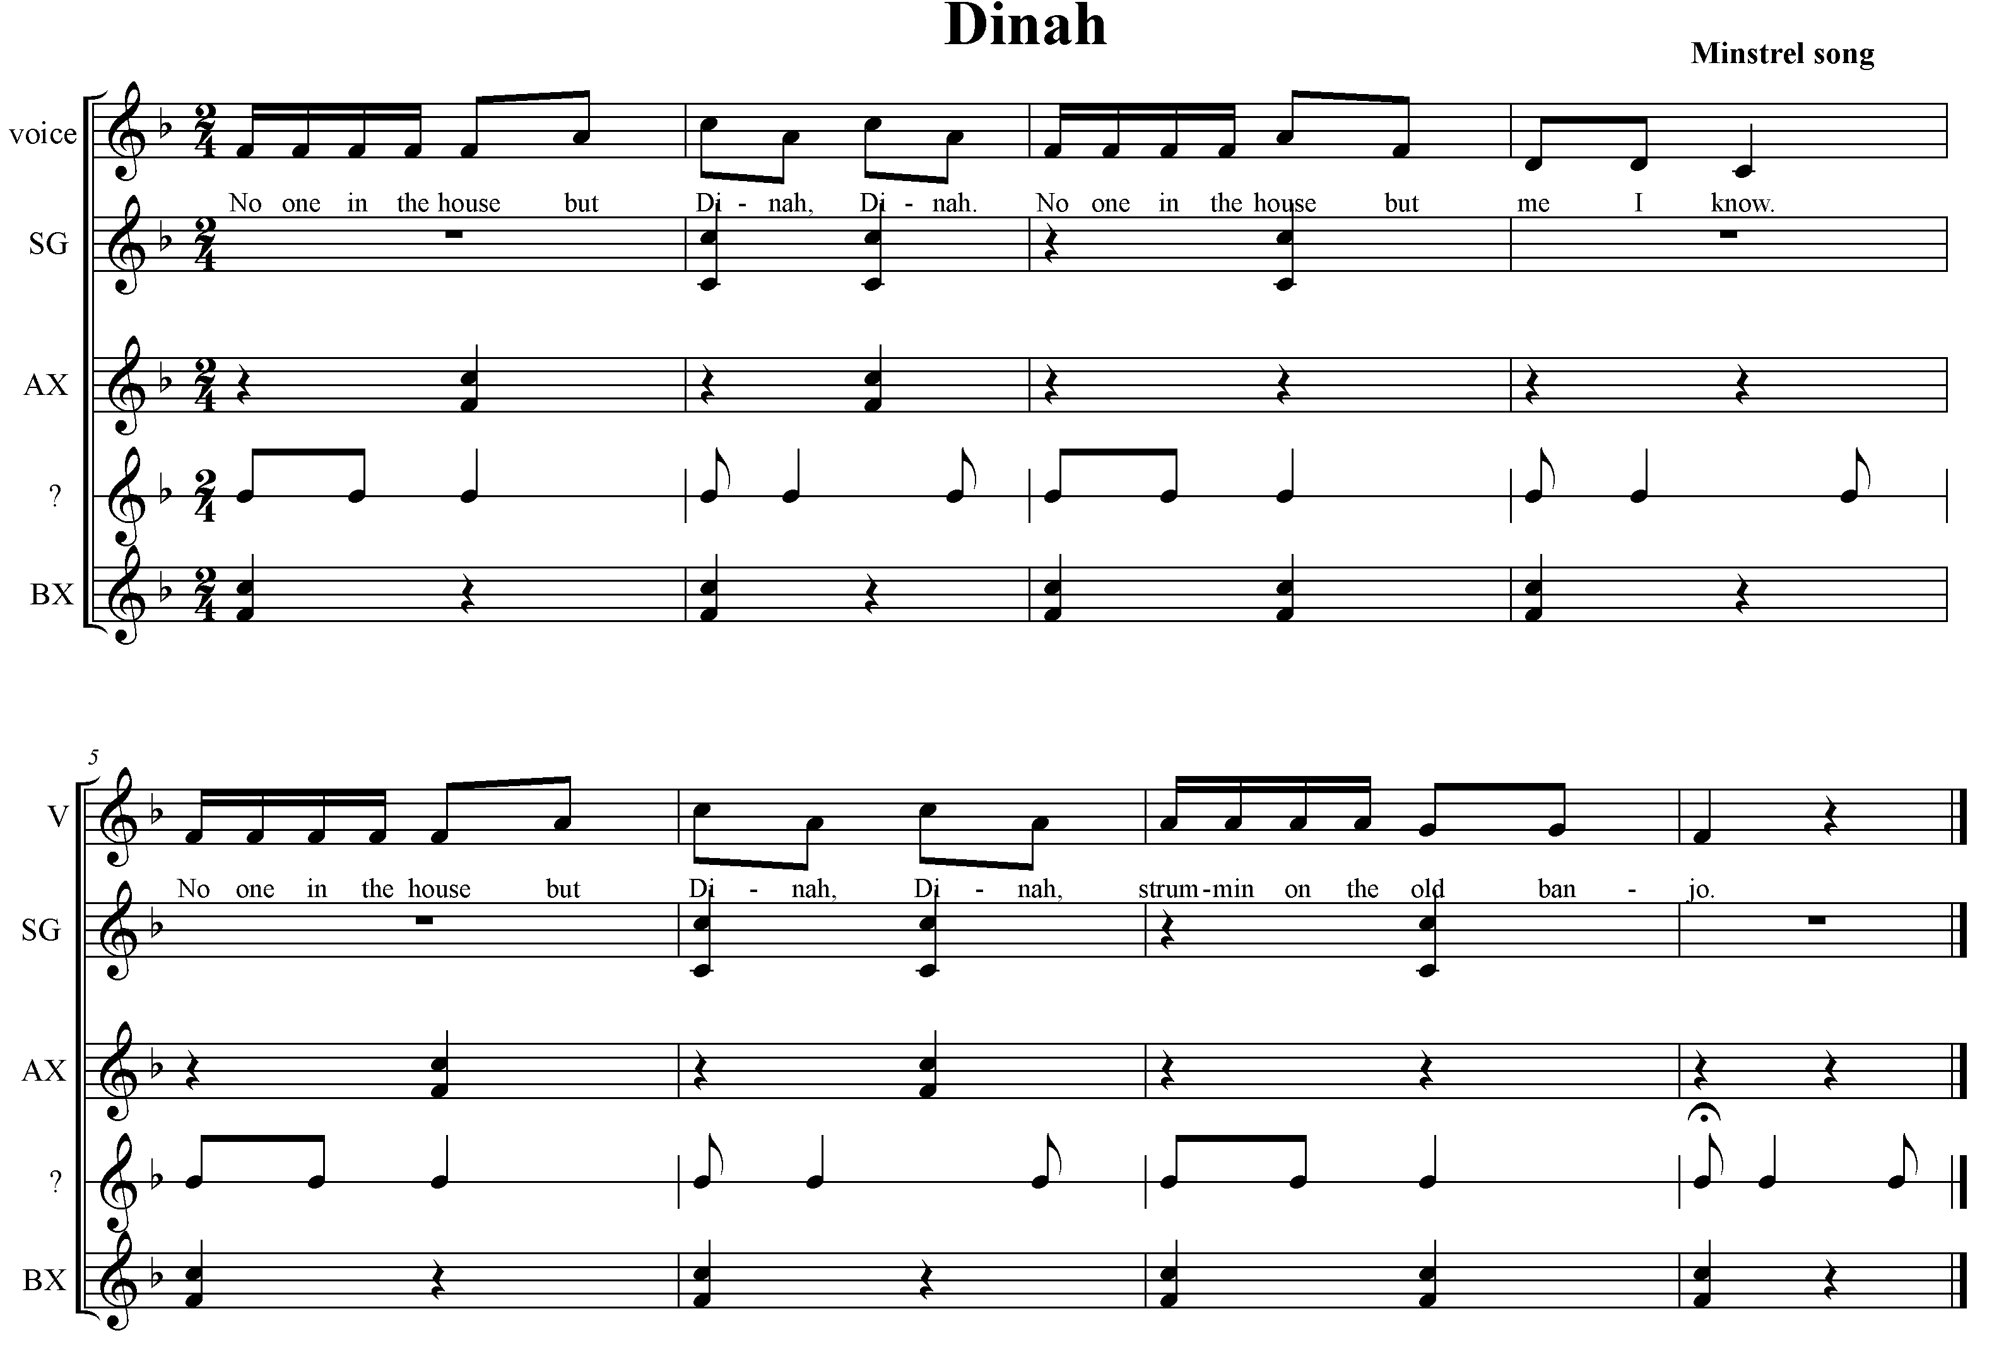

Hand Game

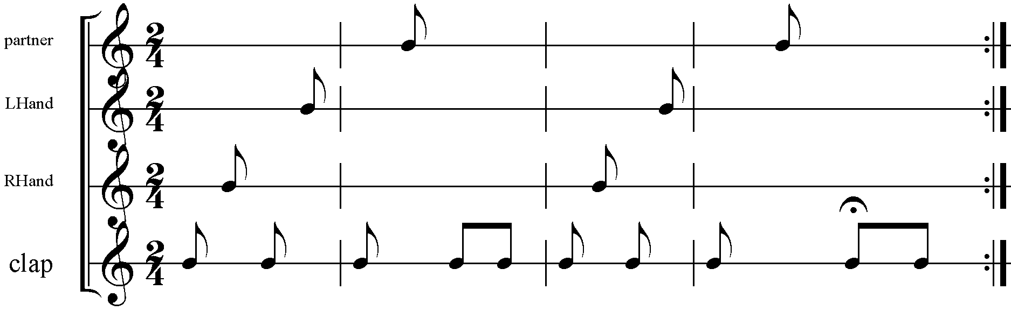

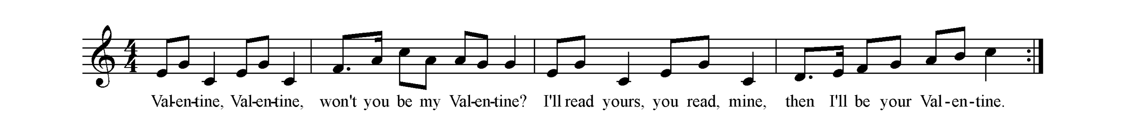
Example – Song in 3/4, 2/4

Teaching Sequence: Partners facing, scattered formation
- Echo melody ( S M R D ) with solfege hand signs
- Partners create a hand game/body percussion game to perform to song in each meter.
- Partners create an interlude to facilitate moving from one meter to the other.
- Share with class

IMPROVISATION
“To perform or provide without previous preparation or to compose on the spur of the moment” is to improvise according to Webster.

In Orff-Schulwerk, improvisation is key to the student’s exploration and participation in making and creating music. It is vital to allow the students, at many stages of learning music, the space to ‘play with’ the concepts and skills you are teaching them. This way, the child becomes the owner of his/her music making no matter how simple or complex it is. Beginning experiences improvising can be as simple as making choices. Begin with movement, vocal sounds, body percussion and eventually progresses to unpitched and pitched instruments. Providing sequential, logical and non-threatening ways insures success and confidence, (even for adults!)

Example: ‘Filling in the space’

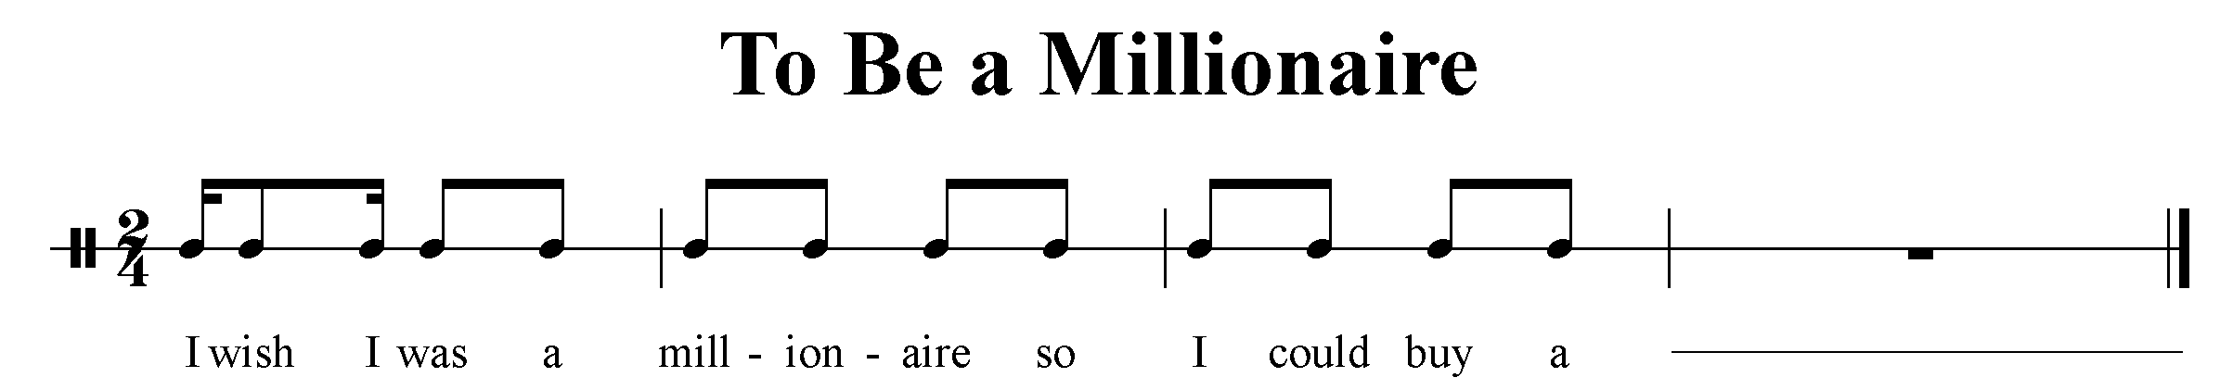
Teaching Sequence:
- In seated circle, with pulse ostinato (class creates), speak phrase
- On the last 2 beats, student “fills in”
- Encourage pulse to be continuous, not ‘dropping the beat’
- Make up new phrases to complete.

- Question and Answer should be equal in phrase length.
- There should be some common element between them; rhythmic, melodic,..
- Question should lead right up to the answer (usually 8 beats) while the answer has a final point, usually ending on 7 ( in an 8 beat phrase) with a rest to “frame” the answer. The visual below might help.
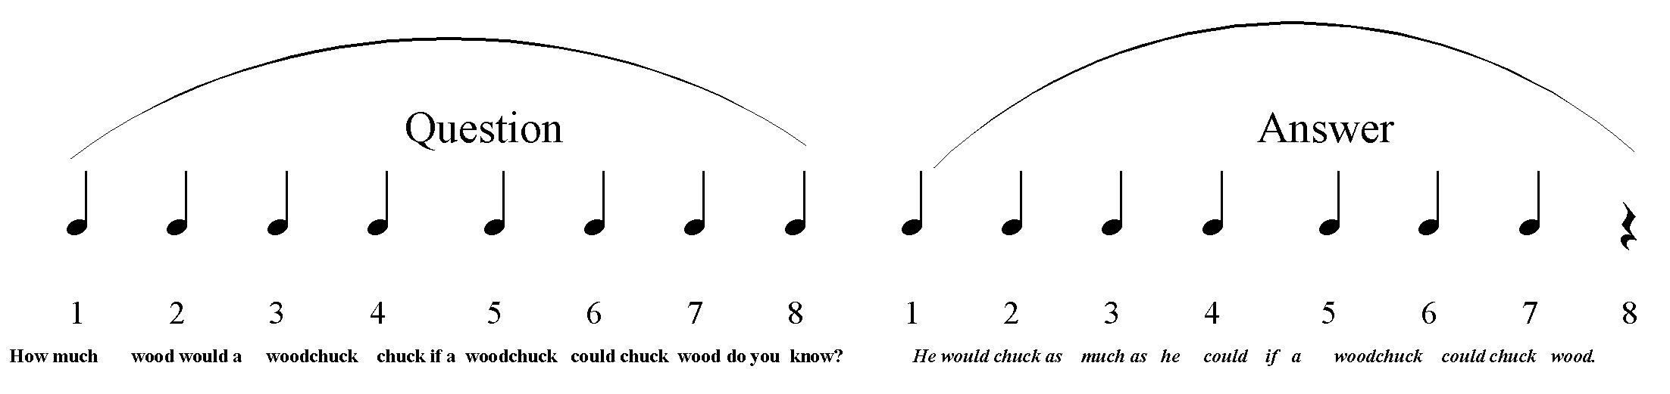

Below are some examples of patterns that illustrate question and answer. Notice similar content in the answer- it contains rhythmic content of the question without repeating it verbatim. Also notice the final point at the end of the answer.
---------------Question --------------------- -------------Answer----------------------

RONDO
Of all of the instrumental forms, the rondo is the most useful and fundamental.
It provides a formal structure for improvisation and can be used to combine different modes of expression from speech to recorder, unpitched to pitched.
The rondo in it’s simplest form is A B A C A . Notice that the return to the A section occurs after each contrasting section. The form can be expanded to any number of contrasting sections as long as you return to A. The contrasting sections can be taught or more likely, improvised. The following options for improvisational sections might be;
Group - Solo; Solo – Group; Group – Group

The use of the Rondo also allows for change in meter, key, timbre, movement, text…
As a teacher, even the smallest or shortest activity could be set in a Rondo, allowing further expansion immediately or weeks later. Performance pieces work well in Rondo as it allows many children to participate.

Example: Rondo for Speech and movement.

A (speak, snapping off beats) Hey There Everybody! S.M.
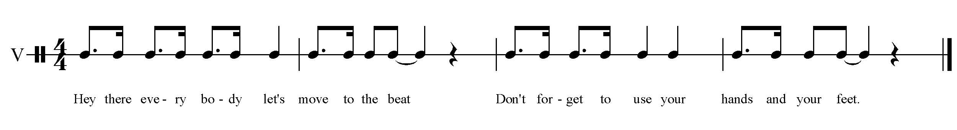
B Students choose a way of moving (locomotor movement) to the beat, accompanied by hand drum (teacher).

C Students choose a different locomotor movement to temple blocks

PART SINGING: Melodic ostinati with solfege, warm-up:

- Echo solfege patterns
- Divide class into two parts
- Part 1 sings S-M, half note ostinato; other half echoes teacher; switch
- Try in three groups, with 2 groups singing a complementary ostinato

Example: Vocal Ostinato
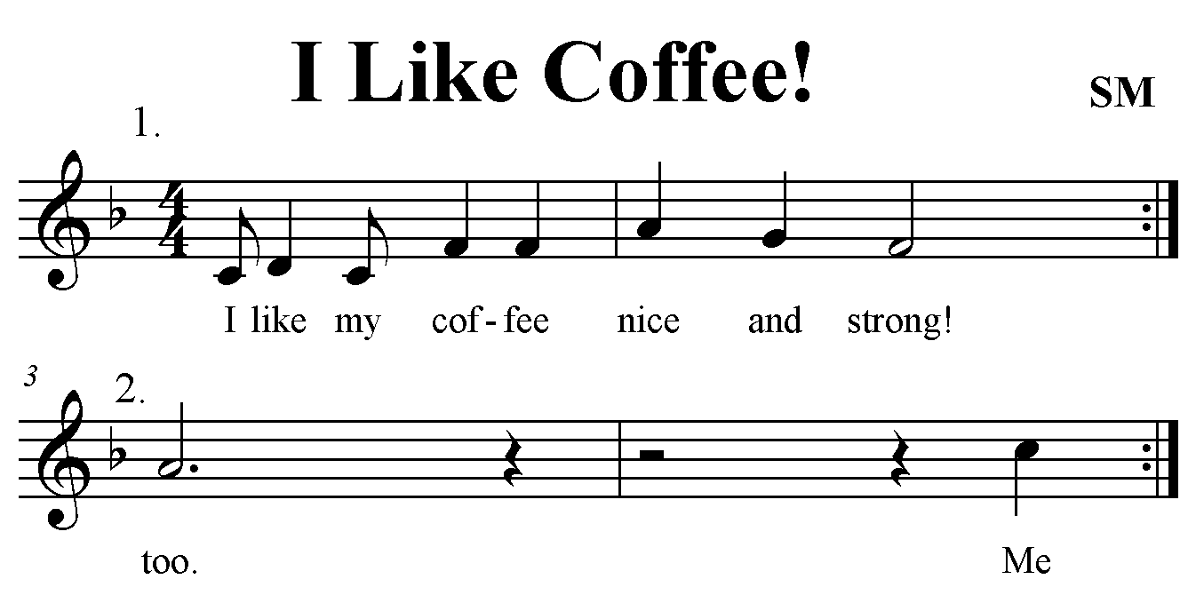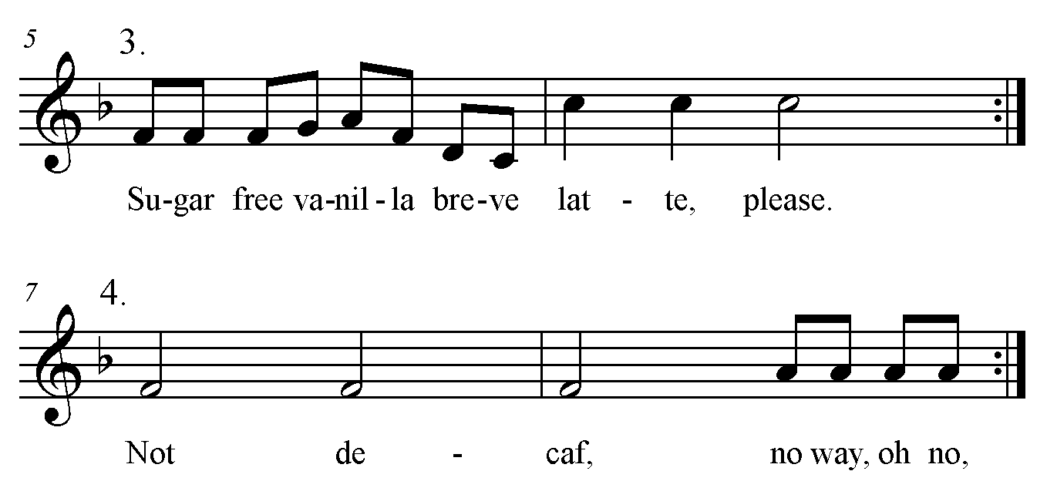
Teaching Sequence:
- Teach each ostinato by rote or with solfege or notation until each is secure

- Play switching game: teacher holds up 1-4 fingers, students sing that ostinato.
- Divide and combine; class creates different presentations
- Create actions or small choreography if desired.

CLASSIFICATION AND RANGES

Four Levels of Sound

Voice | Body Percussion | Unpitched Percussion | Pitched Percussion
Soprano | Snap | Metals | Soprano Glockenspiel
Alto | Clap | Woods | AG SM SX
Tenor | Patschen | Membranes | AX AM
Bass | Stomp | Large Percussion | BX BM  (CBB-8va lower)

Classification of Instrumentarium

Voice | Glockenspiel | Metallophone | Xylophone
Soprano | Soprano Glockenspiel | Soprano Metallophone | Soprano Xylophone
Alto | Alto Glockenspiel | Alto Metallophone | Alto Xylophone
Tenor |  |  | (Tenor Xylophone)
Bass |  | Bass Metallophone | Bass Xylophone  (CBB-8va lower)

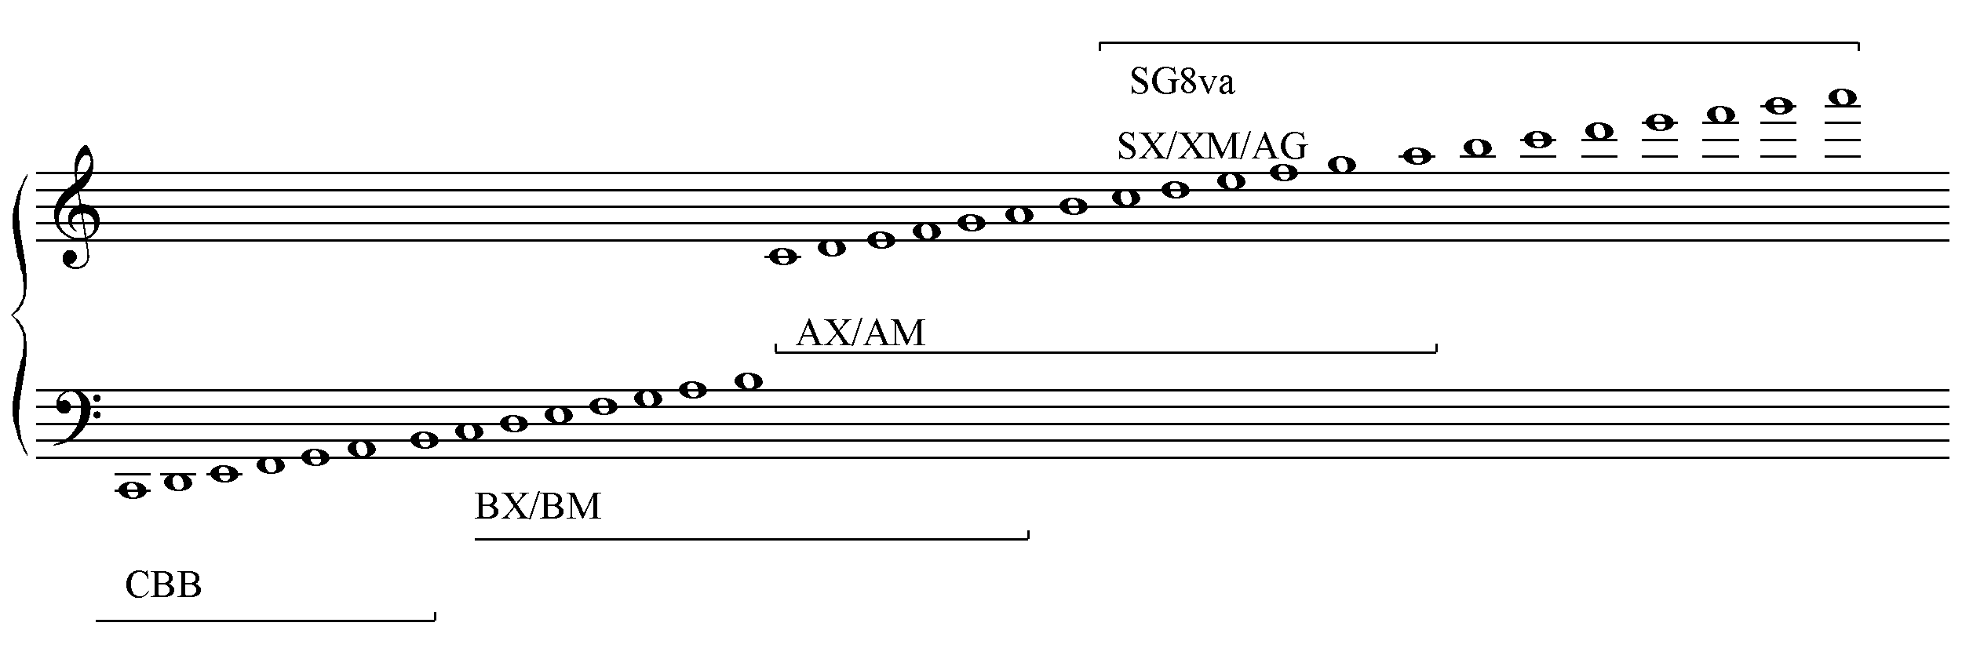

INSTRUMENTARIUM

ORDER OF INSTRUMENTS ON A SCORE

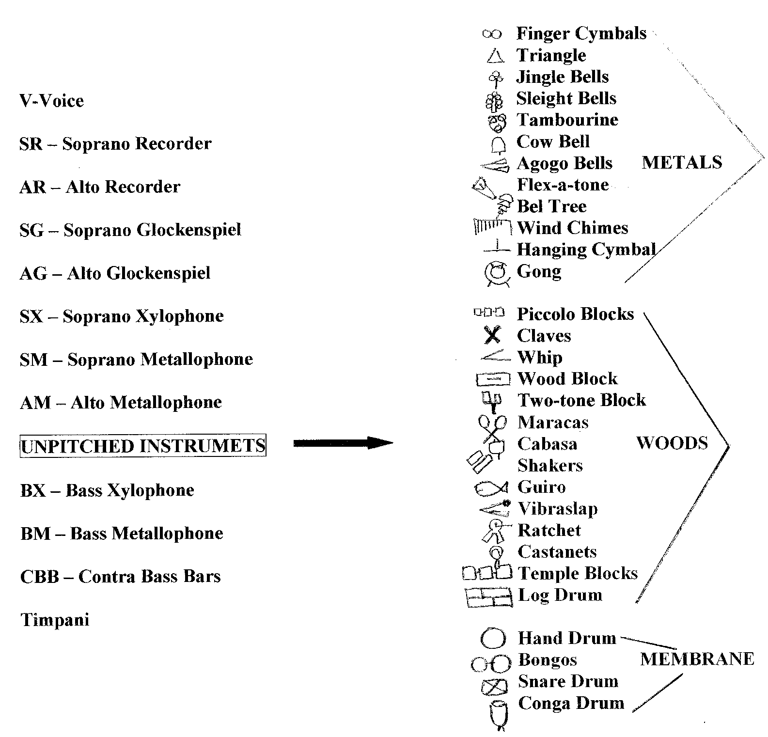

APPENDIX C:

CURWEN (SOLFEGE) HAND SIGNS
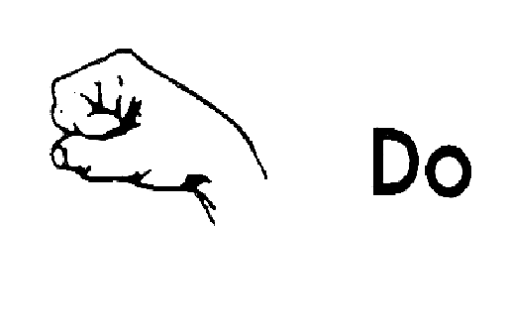
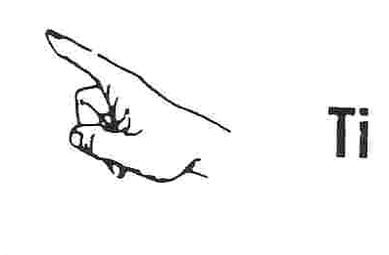
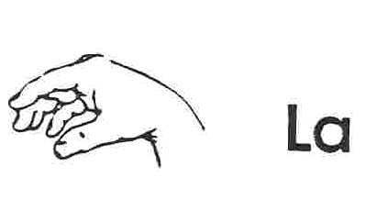
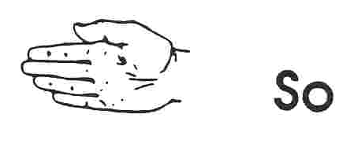
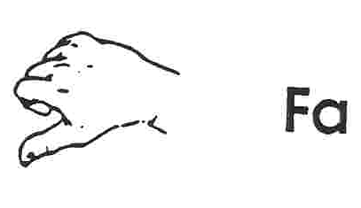
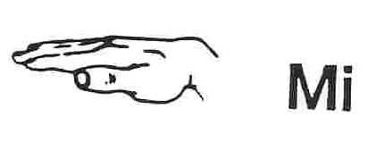
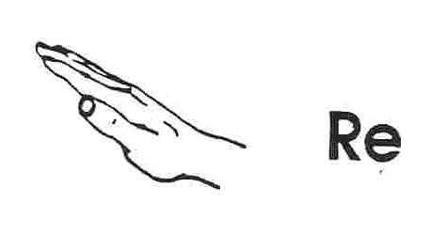

ONTONGENESIS OF MELODY

BITONIC

TRITONIC

TETRATONIC

FOLKLORIC

PENTATONIC

HEXATONIC

HEPTATONIC

PENTATONIC SCALES

PENTATONIC SCALES are basic to the Orff instrumentarium. The same notes are used for Do (Major) centered scales and the corresponding or relative La (minor) scales. The tonal center shifts without having to change the bars on the instruments. The pentatonic scale is absent of half steps, and is made up of only whole steps. Do Re Mi Sol and La.
The advantages to using this pentatonic scale are:

- Melodically, there is no tension
- There are no half-steps, which are difficult to sing in tune.
- There is no harmonic tension.
- All notes sound together without dissonance, assuring early success with instrumental improvisation
- It is a universal scale with an enormous amount of literature.

On the barred instruments we use, there are three true major pentatonic scales.
Each of these major pentatons has a la based pentaton. The notes in both major and minor are the same, but the tonal center is different.

= Do tonal center
= La tonal center

C major
G major
C D E G A C D E G A

D E G A B D E G A

F major
C D F G A C D F G A

When playing in the pentatonic scale on barred instruments, notes that are not used (half steps) can be removed.

D E F# A B D E F# Adding the F# bar allows the
transposed D pentatonic to be used.

APPENDIX G: Brief History of Carl Orff

A Brief history of Carl Orff ~ Born 1895 in Munich Germany- died 1982
Baby Carl was born in a big three-story house at the edge of Munich. It had a nice front yard with tall horse chestnut trees in it and a big back yard full of trees and wildflowers. His mother had a special flower garden, and he loved to play there. Thus, the many references to wild flowers.
His father was an army officer. They lived near his father's base. The practice field for the army band was across from the Orff's house, and it was fun to listen to the music.
Carl's mother played piano. They say that even when he was little Carl liked all kinds of music. When he was old enough to crawl, he liked to sit under the piano besides his mother's feet and listen to her play. He would pound on the floor to the beat of the music.
When he was old enough, Carl begged his mother to let him play on the keys with her. She would sometimes take his high chair over to the piano and let him sit beside her and "play" along.
Finally when he was five, his mother began to give him regular music lessons. His little fingers got tired practicing exercises, but he was excited to learn how to read and write down music. Paper was quite valuable at that time, so children learned to write on slates that could be erased and used over and over again.
Carl's mother wrote five lines for a staff and then together the two of them wrote down a lullaby he had made up. His mother added some notes for a simple accompaniment, and there was his first composition!
When he was nine years old he started writing stories and poems. He began a special project of collecting all the information he could find about plants that had been used at some time for medicine or magic. He studied science books and fairy tales for this hobby.
Carl had a little sister, Mia, who was three years younger than he was. The two got along quite well. They would play four-handed piano music together. When young Carl wrote little songs, Mia would perform them for the family.
From the time he was three, his family spent summers in the country in a farmhouse they rented near a large lake, the Ammersee. There were farm fields, wildflowers and cattle near the lake, and the beautiful Alps Mountains in the distance to look at. Carl Orff always loved the beauty of the country.
- When Orff was 16 he discovered the music written by a French composer named Claude Debussy. Orff was so interested in the sounds Debussy used in his music that he went to a lot of trouble to find copies of his favorite pieces. He was excited studying the music, figuring out why it had such a special sound.
Debussy had heard unfamiliar music from China, India and Java at a special world's fair in Paris in 1889, before Orff was born. At the fair there were huge powerful gongs and elegant dragon-shaped instruments like metallophones that were decorated with gold. Debussy went day after day to hear the colorful orchestras. He borrowed musical ideas from the exciting things that he had heard.
Carl Orff was so interested in this that he went to a museum in Munich and studied all the instruments they had from the Far East. He got close to a large gong and quietly played it. Much later he recalled how thrilled he was with the sound. He felt like there was a whole exciting world of music in those instruments that nobody in Germany was using at that time.

CHRONOLOGY OF ORFF SCHULWERK

1895
Carl Orff is born in Munich on July 10
1898
Birth of his sister Mia
1900
Begins learning piano at age 5
1904
Writes long and short musical pieces for his own puppet theater, poems
1912-1914
Studies composition at the Munich Music Academy
1914
Continues studies with Hermann Zilcher
1916
Kapellmeister at the Munich Chamber Theater
1917
Enlistment for military service in the First Bavarian Field Artillery regiment.
1918
Orff is invited to become Kapellmeister at the National Theater in Mannheim under Wilhelm Furtwängler; moves later to the Court Theater of the Grand Duchy of Darmstadt.
1920-25
Married to Alice Solscher
1920
Studies with Heinrich Kaminski in Ried/Upper Bavaria
1921
Birth of his daughter, Godela
1923
Orff meets Dorothee Günther
1924
Founding of the Günther School in Munich
1925
World premiere of Orpheus, a free arrangement of L’Orfeo by Monteverdi
1930
World premiere of Entrata after William Byrd in Königsberg
1937
World premiere of Carmina Burana in Frankfurt/Main
1939
World premiere of Der Mond at the Bavarian State Opera in Munich
1953
Married to Alice Willert

1943
World premiere of Die Kluge in Frankfurt/Main and of Catulli Carmina in Leipzig
1947
World premiere of Die Bernauerin in Stuttgart
1948
The Bavarian Radio broadcasts its first educational program:Orff Schulwerk – Music for Children
1949
World premiere of Antigonae in Salzburg
1950-54
Orff Schulwerk – Music for Children is published by Schott Verlag in Mainz
1950-60
Teaches the master class in composition at the Conservatory of Music in Munich
1953
World Premiere of Trionfo di Afrodite at the Scala opera house in Milano
1954-59
Married to Luise Rinser
1956
Recipient of the “Pour le mérite” medal for sciences and art
1959
World premiere of Oedipus der Tyrann at the Württemberg State Theater in Stuttgart Receives an honorary doctorate from the University of Tübingen
1960
Married to Liselotte Schmitz
1962
Lectures on the Schulwerk in Japan and Canada Lectures on the Schulwerk in Portugal Lectures in Egypt and Senegal
1968
World premiere of Prometheu
1972
Receives honorary doctorate from the University of Munich and the Cross of Merit with star and shoulder sash of the Federal Republic of Germany
1973
World premiere of De Temporum Fine Comoedia,“A Play of the End of Time.” Vigilia in Salzburg
1975-81
Work on the eight-volume documentation on Carl Orff and his works
1982
Carl Orff dies on March 29 in Munich and is buried in the Chapel of Sorrow in the monastery and pilgrimage church of Andechs

SELECTED BIBLIOGRAPHY

Basic Orff, Publications and Texts

American Edition, Music for Children. Three volumes: Preschool, Primary and Upper Elementary.
Schott Music Corporation, 1977.

CHOKSY, LOIS. The Kodaly Context. Englewood Cliffs, New Jersey: Prentice- Hall, 1981.

FRAZEE, JANE. Discovering Orff. New York, N.Y.: Schott Music Corp., 1987.

KEETMAN, GUNILD. Elementaria. Schott Music Corp., 1987.

MCRAE, SHIRLEY W. Directing the Children’s Choir: A Comprehensive Resource. New York, N.Y.:
Schirmer Books, 1991.

Music for Children. English Edition, Margaret Murray. Volumes I-V. London:
Schott Music Corp., 1958.

SALIBA, KONNIE..Accent on Orff: An Introductory Approach Prentice Hall, 1991

STEEN, ARVIDA. Exploring Orff: A Teacher’s Guide. Schott, 1992.

Orff Collections, Song Collections

BISGAARD AND STEHOUWER. Musicbook O. MMB, 1976.

BRADFORD, LOUISE LARKINS. Sing It Yourself. Alfred Publishing Co., 1978.

BURNETT, MILLIE. Dance Down the Rain, Sing Up the Corn. R and E Research Associates, 1975.

CARLEY, ISABEL MCNEILL. For Hand Drums and Recorders. Music Innovations, 1983.

ERDEI, PETER. 150 American Folk Songs to Sing, Read and Play.

Boosedy & Hawkes, New York, 1974.

FRAZEE, JANE. This is the Day - Songs for Special Holidays. Schmitt, Hall,
McCreary.

GILPATRICK, ELIZABETH. Round We Go. Alfred Publishing Co., 1984.

GOETZE, MARY. Simply Sung. Folk songs arranged in three parts.

Schott, 1984.

HALL, J. LINCOLN AND ELSIE. Song for Little Singers. Hall-Mack. 1909

JENKINS, ELLA. Jambo and Other Call and Response Songs and Chants.
Smithsonian / Folkways. 1990.

_____________. The Ella Jenkins Song Book for Children. Oak Publications. 1966.

JOHNSTON, RICHARD. Folk Songs North America Sings. E.C. Kerby, Ltd., 1988

KENNEDY, MAUREEN. Circle Round the Zero. MMB., 1974

KERSEY, ROBERT DR. Just Five. Belwin Mills, 1972

KRISKE, JEFF AND DELELLES, RANDY. As American As Apple Pie. KID Sounds, 1993.

__________________. Tyme For a Rhyme: Nursery Rhymes with Music for Children. KID Sounds, 1988.

__________________. Highlighting the Holidays. KID Sounds, 1992.

__________________. Making Most of the Holidays. KID Sounds,1987.

LIBANA. A Circle is Cast. Libana, 1986.

______. A Fire Within. Libana, 1990.

LOCKE, ELEANOR. Sail Away: 155 American Folk Songs to Sing Read and Play. Boosey & Hawkes, 1981.

LOMAX, ALAN. The Folk Songs of North America. Doubleday & Co., 1975

MCRAE, SHIRLEY. Angel at the Door. MMB, 1981

______________. Celebrate. Minneapolis: Augsburg Publishing House, 1984

______________. Chatter with the Angels. MMB, 1980

______________. Glow Ree Bee: Traditional Black Spirituals. Memphis Musicraft Publications, 1982.

______________. Playtime. Memphis Musicraft Publications, 1992.

______________. Sing ‘Round The World: International Folksongs. Vol.I and II.,
Memphis Musicraft Publications, 1990, 1995

MEMPHIS ALL CITY ORFF TEACHERS. Holidays. Memphis Musicraft Publ.

SALIBA, KONNIE. Cockadoodle Tunes. Cockadoodle Tunes, 1977.

______________. Good Morning Songs. Cockadoodle Tunes, 1986.

______________. Welcome in the Day. Cockadoodle Tunes, 1982.

______________. Tunes for Little Children. Cockadoodle Tunes, 1987.

SAMUELSON, MIRIAM. Kukuriku: Hebrew Songs and Dances. Schott, 1978.

TRINKA, JILL. Folksongs, Singing Games and Play Parties, vol. II, III. J. Trinka, 1989.

WILLIAMS, MARK Two-part American Songs. Southern Music Co. 1977.

WILSON, HARRY. Rounds and Canons. Schott.

Poetry Collections

ADAMS, ADRIENNE. Poetry of Earth. Charles Scribner and Sons, 1972.

BARING-GOULD, WILLIAM AND CEIL. The Annotated Mother Goose.
Bramhall House, 1962.

BERRY, JAMES. Classic Poems to Read Aloud. Kingfisher, 1995.

Cherry Blossoms: Japanese Haiku. Mt. Vernon, NY: Peter Pauper Press.

COLE, JOANNA. Anna Banana. Morrow Junior Books. 101 jump rope rhymes

DEREGNIERS. BEATRICE SCHENK. Sing a Song of Popcorn. Scholastic Inc.

DOWELL, RUTH I. Move Over, Mother Goose. Mt. Ranier MD:
Gryphon House, Inc., 1987.

FLORIAN, DOUGLAS. Bing, Bang Boing. Harcourt, Brace and Co.

HOPKINS, LEE BENNETT, ed. Side By Side: Poems to Read Together.
Simon and Schuster, 1988.

LEACH, MARIA. Riddle Me, Riddle Me, Ree. Viking Press.

LEE, DENNIS. Alligator Pie. Houghton Mifflin, 1975.

___________. Jelly Belly. Macmillan of Canada.

PRELUTSKY, JACK. It’s Halloween. Scholastic Books, 1977.
________________. The New Kid on the Block. Greenwillow Books, NY, 1984.

________________. Poems of A. Nonny Mouse. Alfred Knopf, 1989.

________________. Random House Book of Poetry for Children. Random House, 1983.

________________. Read Aloud Rhymes for the Very Young. Alfred Knopf.

WITHERS, CARL. A Rocket in my Pocket. Holt, Rinehart and Winston.

WYNDHAM, ROBERT. Chinese Mother Goose Rhymes. Philomel Books, 1982.

Children’s Literature

AARDEMA, VERNA. Who’s in Rabbit’s House. Dial Press, 1977.

_______________.Why Mosquitos Buzz in People’s Ears. Scholastic, 1975.

ANDREAE, GILES AND DAVID WOJTOWYCZ. Rumble in the Jungle.
Little Tiger Press, 1997.

BOYNTON, SANDRA. Hippos Go Berserk! Aladdin Paperbacks, 1996.

CUYLER, MARGERY. That’s Good, That’s Bad. Henry Holt and Co., 1991.

DEPAOLA, TOMIE. The Legend of the Bluebonnet: an Old Tale of Texas.

G.P. Putnam’s Sons, 1983.

DRAGONWAGON, CRESCENT. Half a Moon and One Whole Star.
Aladdin Books, 1990.

EMBERLEY, BARBARA. Drummer Hoff. Simon and Schuster Inc., 1967.

KALAN, ROBERT. Jump, Frog, Jump. Greenwillow Books, 1981.

KEIKO, KASZA. The Wolf’s Chicken Stew G.P.Putnam’s Sons, 1987.

____________. When the Elephant Walks. The Putnam and Grosset Group

LINDBERGH, REEVE. The Day the Goose Got Loose. Scholastic Inc., 1990.

LIONNI, LEO. Swimmy. Alfred A. Knopf, Inc., 1963.

LONG, JAN FREEMAN. The Bee and the Dream: A Japanese Tale. Dutton
Children’s Books, 1996.

MAHY, MARGARET. Boom, Baby, Boom, Boom! Penguin Group, 1996.

MARTIN, BILL. Brown Bear, Brown Bear, What Do You See? Holt, Rinehart
and Winston, 1967.

___________. Polar Bear, Polar Bear, What Do You Hear? Holt, Rinehart
and Winston.

MCDERMOTT, GERALD. Arrow to the Sun: Pueblo Indian Folktale.

Viking Press, 1974.

__________________. The Magic Tree, a Tale of the Congo.
Puffin Books, 1973.

___________________. The Stonecutter, a Tale from Japan. Viking
Press, 1975.

PINCZES, ELINOR J. One Hundred Hungry Ants. Houghton Mifflin Co., 1993.

RASCHKA, CHRIS. Yo! Yes? Scholastic Inc., 1993.

ROBERTSON, TOM. Coyote Christmas. Great American Opportunities, 1993.

WARD, HEATHER PATRICIA. I Promise I’ll Find You. Firefly Books, 1997.

WOOD, AUDREY. The Napping House. Harcourt Brace, Publisher., 1984.

YASHIMA, TARO. Umbrella. Viking Press, 1958.

VAN LAAN, NANCY. Possum Come a-Knockin’. Dragonfly Books, 1990.

Storytelling Collections

Afro-American Folktales. Pantheon Books, 1985.

BRUCHAC, JOSEPH. Native American Animal Stories . Fulcrum Publ. ,1992.

________________. Native American Stories. Fulcrum Publishing, 1991.

CHASE, RICHARD. American Folk Tales and Songs. Dial Press, 1977.

_______________. Grandfather Tales. Houghton Mifflin Co., 1976.

KAULA, EDNA MASON. African Village Folktales. World Publishing, 1968.

SAWYER, RUTH. The Way of the Storyteller. Penguin Books. 1970.

SCHEER, GEORGE. Cherokee Animal Tales. Holiday House Inc., 1968.

STOUTENBURG, ADRIAN. American Tall Tales. Viking Press, 1966.

Movement

AARON, TOSSI. Puchinella 47: Twenty Traditional American Play Parties.

Philadelphia: Coda Publishing Co., 1978.

ABRAMSON, ROBERT. Rhythm Games for Perception and Cognition.
250 West 94th St., N.Y. 10025, 1973

BURNETT, MILLIE. Melody, Movement, and Language. San Francisco:
R and E Research Associates, Inc.

CHOSKY, LOIS AND DAVID BRUMMITT. 120 Singing Games and Dances
for Elementary Schools. Prentice-Hall

FINDLAY, ELSA. Rhythm and Movement. Summy-Birchard Co., 1971

FULTON, ELEANOR AND PAT SMITH. Let’s Slice the Ice. MMB, 1978

HASELBACH, BARBARA. Dance Education. Schott, 1971

JONES, BESSIE AND BESS LOMAX HAWES. Step It Down: Games,

Plays, Songs and Stories from the Afro-American Heritage.

Harper and Row, 1972

KENNEY, MAUREEN. Circle Round the Zero. MMB., 1974

LANGSTAFF, JOHN. Shimmy Shimmy Coke-Ca-Pop: A Collection of City

Children’s Street Games and Rhymes. Doubleday and Co., 1973

RILEY, MARTHA. English Country Dances. Cassettes and Book.

WEIKART, PHYLLIS. Movement and Dance: A Sequential Approach to
Rhythmic Movement. Ypsilanti, Michigan: High Scope Press, 1983

________________. Teaching Movement and Dance: Intermediate
Folk Dance. High Scope Press, 1984

WIRTH, MARIAN. Musical Games, Fingerplays and Rhythmic Activities
for Early Childhood. West Nyack, NY: Parker Publishing Co., 1983

WUYTACK, JOS AND TOSSI AARON. Joy: Play Sing dance.
Alphonse Leduc, 1972

