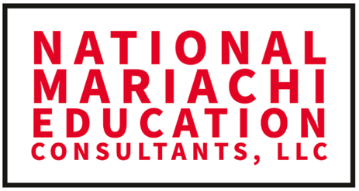

Complete this form and email to marcia@musicedconsultants.net
or call/text 702-630-0518 to get a quote number to generate a Purchase Order from your school.

2023 NATIONAL MARIACHI EDUCATION CONSULTANTS, LLC
QUOTE REQUEST FORM

Name of Person Requesting Quote:
Email Address of Requester:
Requester Cell:
Name of School/District:
School/District Street Address:
School/District City/State/Zip

Complete the no. of attendees, extended amount, and attendee names in the
highlighted boxes just below and email to marcia@musicedconsultants.net
or call 702-630-0518 to receive a Quote Number.

Dates of Event | Description of Expense | No. of Attendees | Each | Extended Amt
June 26-30, 2023 | 1. Mariachi Workshop  (Early Registration) |  | 549.00
 | 2. Mariachi Workshop Registration  (After May 15, 2023) |  | 649.00

Name/s of Attendee/s:

Insert Quote Number Issued by NATIONAL MARIACHI EDUCATION CONSULTANTS, LLC

Date Issued:

